1. PROJECT ABSTRACT

Online shopping is the process whereby consumers directly buy goods, services etc from a seller interactively in real-time without an intermediary service over the Internet. If an intermediary service is present the process is called electronic commerce. An online shop, eshop, e-store, internet shop, webshop, webstore, online store, or virtual store evokes the physical analogy of buying products or services at a bricks-and-mortar retailer or in a shopping mall.

The metaphor of an online catalog is also used, by analogy with mail order catalogs. All types of stores have retail web sites, including those that do and do not also have physical storefronts and paper catalogs. Online shopping is a form of electronic commerce used for business-to-business (B2B) and business-to-consumer (B2C) transactions.
History
Online Shopping pre-dates the IBM PC, Microsoft, Apple, and the Internet/www. In 1979 Michael Aldrich, an English inventor, connected a modified 26" color domestic TV to a real-time transaction processing computer via a domestic telephone line and invented online shopping.
[1] The first recorded B2B online shopping was Thomson Holidays 1981
[2] The first recorded B2C online home shopping was Gateshead SIS/Tesco in 1984.
[3] The world's first recorded online home shopper was Mrs Jane Snowball,72, of Gateshead, England in May 1984.
[4] During the 1980s Aldrich sold many systems mainly in the UK to large corporations, including Ford, Peugeot {then trading as Talbot Motors], General Motors and Nissan. Case studies of some of these systems have survived.
[5] The Nissan system of 1984/85 was revolutionary. It enabled a car buyer on a dealer's lot to buy both car and finance online including credit check.
[6] Aldrich was copied and his ideas were plagiarised. His 1980s systems were as fast as 2010 internet shopping systems but they worked only on dial-up and leased telephone lines. There was no broadband at the time. He never patented his shopping system and his ideas are the basis of internet home shopping.
In 1990 Tim Berners-Lee created the first World Wide Web server and browser
[7] It opened for commercial use in 1991. In 1994 other advances took place, such as online banking and the opening of an online pizza shop by Pizza Hut.
[8] During that same year, Netscape introduced SSL encryption of data transferred online, which has become essential for secure online shopping. In 1995 Amazon expanded its online shopping, and in 1996 eBay appeared. More recently Overstock has also become one of the world largest and reliable online shopping stores.

Webshop

The term 'webshop' has a number of meanings. An online retailler can be called a 'webshop'. Web development and hosting and other web-related activities can be called 'webshops.' Buying online grew because, over time, transportation costs went up and telecom costs went down and access to the internet became commonplace.Online shopping offers a larger selection of goods and services and thus greater choice at optimal prices. The problems with online shopping are that you cannot smell, touch, taste or try what you are buying.

Customers

In general, shopping has always catered to middle class and upper class women. Shopping is fragmented and pyramid-shaped. At the pinnacle are elegant boutiques for the affluent; a huge belt of inelegant but ruthlessly efficient “discounters” flog plenty at the pyramid’s precarious middle. According to the analysis of Susan D. Davis, at its base are the world’s workers and poor, on whose cheapened labor the rest of the pyramid depends for its incredible abundance.
Shopping has evolved from single stores to large malls containing many stores that most often offer attentive service, store credit, delivery, and acceptance of returns. These new additions to shopping have encouraged and targeted middle class women.
In recent years, online shopping has become popular; however, it still caters to the middle and upper class. In order to shop online, one must be able to have access to a computer, a bank account and a debit card. Shopping has evolved with the growth of technology. According to research found in the Journal of Electronic Commerce, if we[who?] focus on the demographic characteristics of the in-home shopper, in general, the higher the level of education, income, and occupation of the head of the household, the more favourable the perception of non-store shopping. An influential factor in consumer attitude towards non-store shopping is exposure to technology, since it has been demonstrated that increased exposure to technology increases the probability of developing favourable attitudes towards new shopping channels.

Online shopping widened the target audience to men and women of the middle class. At first, the main users of online shopping were young men with a high level of income and a university education. This profile is changing. For example, in USA in the early years of Internet there were very few women users, but by 2001 women were 52.8% of the online population. Socio-cultural pressure has made men generally more independent in their purchase decisions, while women place greater value on personal contact and social relations.
Trends

One third of people that shop online use a search engine to find what they are looking for and about one fourth find websites by word of mouth.[10] Word of mouth has become a leading way by which people find shopping websites. When an online shopper has a good first experience with a certain website, sixty percent of the time they will return to that website to buy more.

Books are one of the things bought most online. However, clothes, shoes, and accessories are all very popular things bought online. Cosmetics, nutrition products, and groceries are increasingly being purchased online. About one fourth of travelers buy their plane tickets online because it is a quick and easy way to compare airline travel and make a purchase. Online shopping provides more freedom and control than shopping in a store.

From a sociological perspective, online shopping is arguably the most predictable way to shop. One knows exactly what website to go to, how much the product will cost, and how long it will take for the product to reach them. Online shopping has become extremely routine and predictable, which is one of its great appeals to the consumer.

Product delivery

Once a payment has been accepted the goods or services can be delivered in the following ways.

* Download: This is the method often used for digital media products such as software, music, movies, or images.
* Shipping: The product is shipped to the customer's address.
* Drop shipping: The order is passed to the manufacturer or third-party distributor, who ships the item directly to the consumer, bypassing the retailer's physical location to save time, money, and space.
* In-store pickup: The customer orders online, finds a local store using locator software and picks the product up at the closest store. This is the method often used in the bricks and clicks business model.
* In the case of buying an admission ticket one may get a code, or a ticket that can be printed out. At the premises it is made sure that the same right of admission is not used twice.

2. ORGANIZATION PROFILE

3. COST AND EFFORT ESTIMATION

FUNCTION POINT MODEL: It is based on the visible features of the system that are weighed accordingly to produce an overall score. The intent is to construct a measure of product size that can be available easily in the development process. It is based on the notion of function points regarding as a measure of functionality of the system. The starting point of the construction of the model is to determine the number of items occurring in the system.
The items are as follows:
External inputs are the inputs from the user that provide distinct application oriented data. Examples of such inputs are filenames and menu selections.
External outputs are directed to the user, they come in the form of various reports and messages.
User inquiries are interactive inputs requiring the response.
External files deal with all machine readable interfaces on other systems.
Internal files are the master files in the system.
These items are related differently according to their complexity that is given below in the following table.
Item | Simple | Average | Complex
External Inputs | 3 | 4 | 6
External Outputs | 4 | 5 | 7
User Inquiries | 3 | 4 | 6
External files | 7 | 10 | 15
Internal files | 5 | 7 | 10

Here, first the Unadjusted Function Count (UFC) is determined using the formula
UFC = ∑itemi wi
In the second phase, refining the Function Point Count by including Technical Complexity Factor (TCF) and multiplying the value with UFC by using the formula determine Adjusted Function Point Count (FP):
FP = UFC * TCF

Where TCF is calculated using the formula:
TCF = 0.65 + 0.1∑fi
Where fi specifies the detailed factors contributing to the overall notion of complexity.

The various factors are as follows-
- Reliable Backup and Recovery
- Distributed Functions
- Heavily used Configuration
- Operational Use
- Complex Interface
- Reusability
- Multiple sites
- Data Communications
- Performance
- Online Data Entry
- Online Update
- Complex Processing
- Installation Ease
- Facilitate Change
Here each factor is rated on 0 to 5 scales with 0 being irrelevant and 5 standing for essential. If al the factors are irrelevant then the constant 0.65 is used otherwise the constant 1.35 is used.

Considering the Data Automation System the items are as follows-
External inputs – 37 (File no, Mineral Id, Mineral Name, Land Type, Location, GO number, Year of join, Exp Year, Area, . . .)
External outputs – 3 (Confirmation to Do rector, Confirmation to Data Entry Clerk, Test report)
User inquiries – 5 (Availability of location, Validity of client, Selecting mine site, .....)
External Files – (Client info files)
Internal Files – 7 (Minerals & User’s info files)

Considering the Data Automation System, we assume the complexity of all items to be average.

So, UFC = (4*37) + (5*3) + (4*5) + (10*1) + (7*7)
= 148 + 15 + 20 + 10 + 49
=182
TCF = 0.65 + 0.1(5 + 0 + 0 + 5 + 1 + 1 + 0 + 3 + 0 + 0 + 1 + 2)
= 2.45

Therefore FP = UFC*TCF
= 182*2.45
= 445.9

SYSTEM REQUIREMENT SPECIFICATION (SRS)

5. SRS
5.1 INTRODUCTION

The Shopping Cart program allows visitors to your on-line shopping site to collect items in a virtual shopping cart. They may view the contents of their shopping cart at any time and may add or delete items at will. The program automatically calculates the subtotal, sales tax, shipping charges, and grand total. When a visitor decides to check-out, the order information including the buyer's name, address and billing instruction is e-mailed to your order department (or whomever you choose) and a receipt is sent to the shopper.

This is software which helps you to do the major part of online shopping by using this site and can be managed by online; you (or the Customer) can do the all major transaction in a secured way. Here the customer will feel a virtual shopping by adding the selected product to his cart in addition to that; he can also does bulk addition into the cart before purchasing. This all options are done by session management. To ensure the authentification of the customer, He/She must have to register before proceeding. It provides following standard features of any e-commerce web site:

5.1.1 PURPOSE

Simple systems allow the offline administration of products and categories. The shop is then generated as HTML files and graphics that can be uploaded to a webspace. These systems do not use an online database.

- A high end solution can be bought or rented as a standalone program or as an addition to an enterprise resource planning program. It is usually installed on the company's own webserver and may integrate into the existing supply chain so that ordering, payment, delivery, accounting and warehousing can be automated to a large extent.

- Other solutions allow the user to register and create an online shop on a portal that hosts multiple shops at the same time.

- Open source shopping cart packages include advanced platforms such as Interchange, and off the shelf solutions as Avactis, Satchmo, osCommerce, Magento, Zen Cart, VirtueMart, Batavi and PrestaShop.

- Commercial systems can also be tailored to ones needs so that the shop does not have to be created from scratch. By using a framework already existing, software modules for different functionalities required by a web shop can be adapted and combined.

5.1.2 SCOPE

- Online stores are usually available 24 hours a day, and many consumers have Internet access both at work and at home.
- Other establishments such as internet cafes and schools provide access as well. A visit to a conventional retail store requires travel and must take place during business hours.
- Searching or browsing an online catalog can be faster than browsing the aisles of a physical store.
- One can avoid crowded malls resulting in long lines, and no parking. Consumers with dial-up Internet connections rather than broadband have much longer load times for content-rich web sites and have a considerably slower online shopping experience.
- Some consumers prefer interacting with people rather than computers because they find computers hard to use.
- Not all online retailers have succeeded in making their sites easy to use or reliable. On the other hand, a majority of stores have made it easy to find the style one is looking for, as well as the price range that is acceptable making the shopping experience quick and efficient.
- The internet has made shopping an almost effortless task.

5.1.3 DEFINATIONS, ACRONYMS, ABBREVATIONS

Class diagram:
Shows a collection of static model elements such as classes and types, their contents, and their relationships. Building blocks of the model: class & relationships.

Object diagram:
Depicts objects and their relationships at a point in time, typically a special case of either a class diagram or a communication diagram.

Package diagram:
Shows how model elements are organized into packages as well as the dependencies between packages. Higher-level model organization.

Behavioral Diagrams:
A type of diagram that depicts behavioral features of a system or business process. This includes activity, state machine, and use case diagrams as well as the four interaction diagrams.

Use case diagram:
External functionality of a system. Shows use cases, actors, and their interrelationships.

Sequence diagram:
Models the sequential logic, in effect the time ordering of messages between classifiers. Time-ordered sequences of interacting objects.

Collaboration diagram:
Object-centered interaction of a society of objects.

State transition diagram:
Describes the states an object or interaction may be in, as well as the transitions between states. Formerly referred to as a state diagram, state chart diagram, or a state-transition diagram. The life history of a single object.

Activity diagram:
Depicts high-level business processes, including data flow, or to model the logic of complex logic within a system. Procedural flow of control within an overall interaction.

Component diagram:
Depicts the components that compose an application, system, or enterprise. The components, their interrelationships, interactions, and their public interfaces are depicted. The dependencies among software units

Deployment diagram:
Shows the execution architecture of systems. This includes nodes, either hardware or software execution environments, as well as the middleware connecting them. The distribution and interaction of components and objects on computational nodes

Interaction diagrams:
A subset of behavior diagrams which emphasize object interactions. This includes communication, interaction overview, sequence, and timing diagrams.

SRS | System Requirement Specification
BRD | Business Requirement Document
URD | Use-case Requirement Documentation
SC | Shopping cart
CUST | Customer
SP | Sales person
WHE | Warehouse employee
LI | LOGIN
LO | LOGOUT
REG | Register
VP | View products
PO | Place order
MP | Make payment
CP | Change profile
RO | Receive order
VP | Verify payment
PB | Print-In-Voice bills
NW | Notify warehouse about order
VR | View new registrations
MNGP | Manage products information online(i.e., Update , Delete, Create)
US | Update order status online
CS | Check delivery status online
SDLC | System Development life cycle
SFD | System feature documentation

5.1.4 REFERENCES

SOFTWARE ENGINEERING:
By Roger.S.Pressman

SQL FOR PROFESSIONALS:
By Jain

ASP.NET Unleashed
By Sams

ASP.NET Quick starts
By Microsoft

5.1.5 SOFTWARE DEVELOPMENT METHODOLOGY

Software engineering is the practice of using selected process techniques to improve the quality of a software development effort. This is based on the assumption, subject to endless debate and supported by patient experience, that a methodical approach to software development results in fewer defects and, therefore, ultimately provides shorter delivery times and better value. The documented collection of policies, processes and procedures used by a development team or organization to practice software engineering is called its software development methodology (SDM) or system development life cycle (SDLC).

All projects can be managed better when segmented into a hierarchy of chunks such as phases, stages, activities, tasks and steps. In system development projects, the simplest rendition of this is called the "waterfall" methodology, as shown in the following figure:
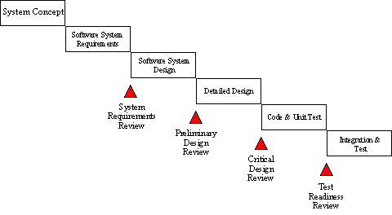
In looking at this graphic, which was for major defence systems developments, please note this presumes that the system requirement have already been defined and scrubbed exhaustively, which is probably the most important step towards project success. Nevertheless, the graphic illustrates a few critical principles of a good methodology:
- Work is done in stages,
- Content reviews are conducted between stages, and
- Reviews represent quality gates and decision points for continuing.
The waterfall provides an orderly sequence of development steps and helps ensure the adequacy of documentation and design reviews to ensure the quality, reliability, and maintainability of the developed software. While almost everyone these days disparages the "waterfall methodology" as being needlessly slow and cumbersome, it does illustrate a few sound principles of life cycle development.

5.2 SYSTEM ANALYSIS

5.2.1 STUDY OF THE EXISTING SYSTEM

- In existing system shopping can done in a manual way, the customer has to go for shopping, and then he is having the possibility to choose the products what ever he wants.
- It is a time consuming process.
- Thus, the system has to be automated.

5.2.2 PROBLEMS IN EXISTING SYSTEM

- In Existing System the Customer is completely depending on the manual process for buying the products.
- Manual process is a time consuming factor. And when customer approaches for a manual shopping directly, actually he/she does not have an idea about things like, price range, items, etc.,
- The time which has been spent by the customer in manual shopping can equates to multiple number of shopping. As customer can sit at home and browse in a fraction of seconds.
- Thus we need to change to a system like “Online Shopping “.

5.2.3 PROPOSED SYSTEM

- Sends receipt to customer
- Accommodates up to four types of shipping
- Allows owner to predefine sales tax based a specific state
- Tracks purchases even if user clicks the back button
- Tracks each customer by Shopper ID (SID) (does not use cookies)

5.2.4 REQUIREMENT SPECIFICATION

5.2.4.1 FUNCTIONAL REQUIREMENTS

- System should have a provision for customer to view/order products.
- System should have a facility for sales person to update the products & order details.
- System should allow the sales person to create/update/delete invoice bills.
- System should have a provision for warehouse employee to create/delete products information.
- System should facilitate the ware house employee to view information about customers.

5.2.4.2 NON – FUNCTIONAL REQUIREMENTS

- The users of the system should be provided user id and password along with the well defined access privileges.
- 24X7 internet connectivity should be provided for well functioning of the system.
- Systems should be provided with proper backup media and resources to handle system crash scenarios.

5.3 FEASIBILITY STUDY

Preliminary investigation examines project feasibility; the likelihood the system will be useful to the organization. The main objective of the feasibility study is to test the Technical, Operational and Economical feasibility for adding new modules and debugging old running system. All systems are feasible if they are given unlimited resources and infinite time. There are aspects in the feasibility study portion of the preliminary investigation:

- Technical Feasibility
- Operation Feasibility
- Economical Feasibility

5.3.1 OPERATIONAL FEASIBILITY

Proposed projects are beneficial only if they can be turned into information systems that will meet the organizations operating requirements. Simply stated, this test of feasibility asks if the system will work when it is developed and installed. Are there major barriers to implementation? Here are questions that will help test the operational feasibility of a project.
Is there sufficient support for the project from management from users? If the current system is well liked and used to the extent that persons will not be able to see reasons for change, there may be resistance.

Are the current business methods acceptable to the user? If they are not, Users may welcome a change that will bring about a more operational and useful systems.
Have the user been involved in the planning and development of the project? Early involvement reduces the chances of resistance to the system and in general and increases the likelihood of successful project.
Since the proposed system was to help reduce the hardships encountered. In the existing manual system, the new system was considered to be operational feasible.

User-friendly
Customer will use the forms for their various transactions i.e. for adding new routes, viewing the routes details. Also the Customer wants the reports to view the various transactions based on the constraints. Theses forms and reports are generated as user-friendly to the Client.

Reliability
The package wills pick-up current transactions on line. Regarding the old transactions, User will enter them in to the system.

Security
The web server and database server should be protected from hacking, virus etc

Portability
The application will be developed using standard open source software (Except Oracle) like Java, tomcat web server, Internet Explorer Browser etc these software will work both on Windows and Linux o/s. Hence portability problems will not arise.

Maintainability
The system called the ewheelz uses the 2-tier architecture. The 1st tier is the GUI, which is said to be front-end and the 2nd tier is the database, which uses My-Sql, which is the back-end.
The front-end can be run on different systems (clients). The database will be running at the server. Users access these forms by using the user-ids and the passwords.

5.3.2 TECHNICAL FEASIBILITY

Evaluating the technical feasibility is the trickiest part of a feasibility study. This is because, at this point in time, not too many detailed design of the system, making it difficult to access issues like performance, costs on (on account of the kind of technology to be deployed) etc. A number of issues have to be considered while doing a technical analysis.

Understand the different technologies involved in the proposed system:
Before commencing the project, we have to be very clear about what are the technologies that are to be required for the development of the new system.

Find out whether the organization currently possesses the required technologies:
Is the required technology available with the organization?
If so is the capacity sufficient?
For instance- “Will the current printer be able to handle the new reports and forms required fort the new system?”

- The technical issue usually raised during the feasibility stage of the investigation includes the following:
- Does the necessary technology exist to do what is suggested?
- Do the proposed equipments have the technical capacity to hold the data required to use the new system?
- Will the proposed system provide adequate response to inquiries, regardless of the number or location of users?
- Can the system be upgraded if developed?

5.3.3 ECONOMICAL FEASIBILITY

Economic feasibility attempts to weights the costs of developing and implementing a new system, against the benefits that would accrue from having the new system in place. This feasibility study gives the top management the economic justification for the new system.

A simple economic analysis which gives the actual comparison of costs and benefits are much more meaningful in this case. In addition this provides to be a useful point of reference to compare actual costs as the project progresses. There could include increased client satisfaction, improvement in product quality better decision making timeliness of information, expediting activities, improved accuracy of operations, better documentation and record keeping, faster retrieval of information, better employee morale.

The computerized system takes care of the present existing system’s data flow and procedures completely and should generate all the reports of the manual system besides a host of other management reports.
It should be built as a web based application with separate web server and database server. This is required as the activities are spread through out the organization customer wants a centralized database. Further some of the linked transactions take place in different locations.

Open source software like TOMCAT, JAVA, Mysql and Linux is used to minimize the cost for the Customer.

5.4 SYSTEM REQUIREMENT STUDY

5.4.1 SOFTWARE REQUIREMENTS

Technology : ASP.NET with Ajax
Programming Language : C#.NET
Database : SQL Server
Tool : Rational Rose
Application Server : IIS

5.4.2 HARDWARE REQUIREMENTS

- Pentium IV processor
- 1 GB RAM
- 80GB HDD

5.5 USER REQUIREMENT DOCUMENT

5.5.1 USE CASE DIAGRAM
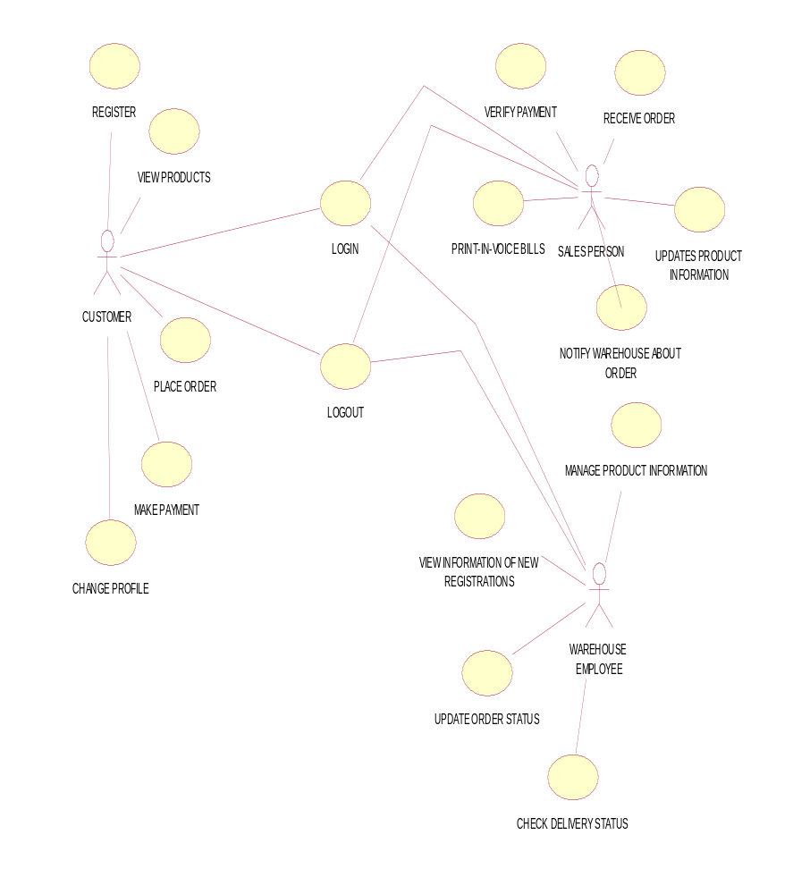

5.5.2 LOOK UP TABLE

S.No | Requirement ID | Requirement Name | Actors | Stable (Y/N) | Priority | Need | Verifiable(y/n)
1 | SC_CUST_LI_01 | Login | Customer | Y | High | Essential | Y
2 | SC_CUST_RG_02 | Register | Customer | Y | High | Essential | Y
3 | SC_CUST_VP_03 | View the products | Customer | Y | High | Essential | Y
4 | SC_CUST_PO_04 | Places order | Customer | Y | High | Essential | Y
5 | SC_CUST_MP_05 | Make payment | Customer | Y | High | Essential | Y
6 | SC_CUST_CP_06 | Change profile | Customer | Y | High | Essential | Y
7 | SC_CUST_LO_07 | Logout | Customer | Y | High | Essential | Y
8 | SC_SP_RO_08 | Receives order | Sales person | Y | High | Essential | Y
9 | SC_SP_VPY_09 | Verify payment | Sales person | Y | High | Essential | Y
10 | SC_SP_PB_10 | Print-in-voice bills | Sales person | Y | High | Essential | Y
11 | SC_SP_NAO_11 | Notify warehouse about order | Sales person | Y | High | Essential | Y
12 | SC_WHE_MPTS_12 | Manage products list online | Warehouse employee | Y | High | Essential | Y
13 | SC_WHE_VNR_13 | View information of new registrations | Warehouse employee | Y | High | Essential | Y
14 | SC_WHE_US_14 | Update order status | Warehouse employee | Y | High | Essential | Y
15 | SC_WHE_CS_15 | Check delivery status | Warehouse employee | Y | High | Essential | Y

5.5.3 USE CASE DOCUMENTATION

Requirement ID | SC_CUST_REG_01
Module Name | Customer module
Use Case Name | REGISTER
Use Case Description | Here using the use case, the Customer will register to the site.
Primary Actor | CUSTOMER
Usecase Diagram | 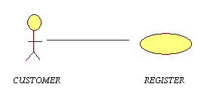
Precondition | Customer wanted to shop in that particular shopping mall.
Post condition | Not applicable.
Basic flow | - Open the site.  - Signup for new registration.  - Fill the profile.  a. Enter name  b. Enter Login Id  c. Enter password  d. Confirm password  e. Enter DOB  f. Enter marital status  g. Enter contact no.  h. Enter email id  i. Enter postal address  4. Clicks on “OK” button.
Input | - Name  - Login Id  - Password  - DOB  - Marital status  - Contact no.  - email Id  8. Postal address
Output | Acknowledgement message stating the confirmation of registration.
Alternate Flows | Mail_ID entered wrongly.  - Display the message asking the user to enter existing mail_ID.  - User enters the correct mail _ID.  - Clicks on OK button.
Special instructions | Password length should be at least ‘6’ characters.

Requirement ID | SC_CUST_LI_02
Module Name | Customer, Sales person, Warehouse employee
Use Case Name | LOGIN
Use Case Description | Here using the Usecase the customer will LOGIN to the site to add products into his cart.
Primary Actor | CUSTOMER, SALES PERSON, WAREHOUSE EMPLOYEE
Use case Diagram | 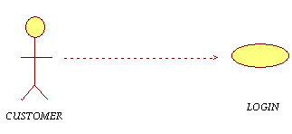
Precondition | To LOGIN, the customer must registered with the complete details.
Post condition | Not applicable.
Basic Flow | - Customer Login the system.  - Enter username.  - Enter Password.  - Clicks on “OK” button.
Input | - Username  - Password
Output | Opens the home page of the site to view or add or remove or purchase the products.
Alternate Flows | - Password entered wrongly.  1. a Display the message asking the user to enter correct password.  1. b Customer corrects the password.  1. c Clicks on “OK” button again.  2. Customer forgets to enter the username.  2.a Display the message asking the user to  Enter username.  2. b Customer enters the username.  2. c Customer clicks on “OK” button again.
Special instructions | Enter correct username and password.

Requirement ID | SC_CUST_VP_03
Module Name | Customer module
Use Case Name | VIEW THE PRODUCTS
Use Case Description | Here using the use case, the Customer will view the products to buy.
Primary Actor | CUSTOMER
Usecase Diagram | 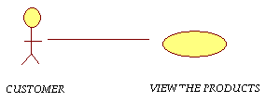
Precondition | - User must have an account.  - Products details must exist in the system.
Post condition | Not applicable.
Basic Flow | - Customer login to the site.  - Enter username  - Enter password  - View the list of products by products category
Input | - Login to the site  - Enter username  - Enter password
Output | View the list of products by products category.
Alternate Flows | Not applicable.
Special instructions | Not applicable.

Requirement ID | SC_CUST_PO_04
Module Name | Customer module
Use Case Name | PLACES ORDER
Use Case Description | Here using the use case, the Customer will add the products to the cart.
Primary Actor | CUSTOMER
Usecase Diagram | 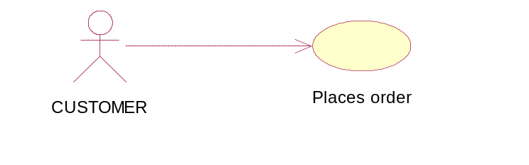
Precondition | - Customer must have an account.  - Products details must exist in the system.  - Customer must know the price range.
Post condition | Order successfully submitted.
Basic flow | - Customer login to the site  - Clicks on view the products link  - Places order to the sales person  - Add item to the cart  - Remove item from cart  - Review the contents of the cart  4. Click “OK” button
Input | - View the products  - Add the items to the cart
Output | Display the list of products which are added to the cart
Alternate Flows | Not applicable.
Special instructions | Not applicable.

Requirement ID | SC_CUST_MP_05
Module Name | Customer module
Use Case Name | MAKE PAYMENT
Use Case Description | Here using the use case, the Customer will pay the bill.
Primary Actor | CUSTOMER
Usecase Diagram | 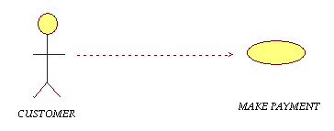
Precondition | - Customer must have an account.  - Customer must know the products price range.
Post condition | Successfully paid.
Basic flow | - Customer must login to the site  - Enter username  - Enter password  - View the products  - Add products to the cart  - Review contents into the cart  - Make payment of the bill  - Credit card type  - Credit card holder name  - Credit card no.  - Valid till  - CVV code  8. Clicks on “OK” button
Input | - Select credit card type  - Enter credit card holder name  - Enter credit card no.  - Enter validity till  - Enter CVV code
Output | Receives the bill.
Alternate Flows | - If user forget to enter any mandatory field  - Display the message asking the user to enter the forgotten field  - User fill the fields  - Clicks “OK” button again  - Validity date is wrongly entered(month is greater than 12)  - Display the message asking the user to enter correct valid date till  - User corrects the valid date  - Clicks “OK” button again  - CVV code is wrongly entered(it should be numbers not characters)  - Display the message asking the user to enter correct CVV code  - User corrects the CVV code  - Clicks on “OK” button again
Special instructions | Not applicable.

Requirement ID | SC_CUST_CP_06
Module Name | Customer module
Use Case Name | CHANGE PROFILE
Use Case Description | Here using the use case, the Customer will change profile to the site, if necessary.
Primary Actor | CUSTOMER
Usecase Diagram | 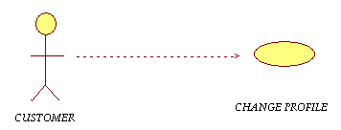
Precondition | - Customer profile must exist in the system.  - Customer must login to the system.
Post condition | Updated successfully.
Basic flow | - Login to the site  - Enter username  - Enter password  - View different links on page  - Clicks on required link  - Click Change profile  - Enter name  - Enter login Id  - Enter password  - Confirm password  - Enter DOB  - Enter marital status  - Enter Contact no.  - Enter email id  - Enter postal address  7. Clicks on “OK” button
Input | - Name  - Login Id  - Password  - DOB  - Marital status  - Contact no.  - email id  - postal address
Output | New updated profile.
Alternate Flows | - If user forget to enter any mandatory field  - Display the message asking the user to enter forgotten field.  - User fill the profile which is empty  - Clicks on “OK” button
Special instructions | Not applicable.

Requirement ID | SC_CUST_LO_07
Module Name | Customer, Sales person,
Use Case Name | LOGOUT
Use Case Description | Here using the use case, the Customer will log out from the site.
Primary Actor | CUSTOMER
Usecase Diagram | 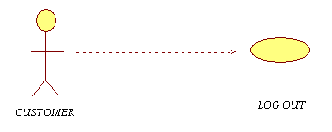
Precondition | - Customer must have an account.  - Customer must login to the system.
Post condition | Successfully logout from the page.
Basic flow | - open the site  - Enter username  - Enter password  - View different links on the page  - Click on required link  - Buy products online  - if not satisfied with the existing products  - Clicks on log out link
Input | - Required URL  - LOG IN  - username  - Password  - LOG OUT
Output | - Log out from the page  - Click on CLOSE button to come out of the site.
Alternate Flows | Not applicable.
Special instructions | Not applicable.

Requirement ID | SC_SP_RO_08
Module Name | Sales person module
Use Case Name | RECEIVES ORDER
Use Case Description | Here using the use case, the Sales person receives order from customer.
Primary Actor | SALESPERSON
Usecase Diagram | 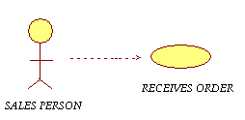
Precondition | Customer must place order
Post condition | Verify the details of payment and delivers order to the customer.
Basic flow | - Open the system  - Enter URL  - Enter username  - Enter password  - Clicks on Receive order  - Verify payment details of each customer  - Delivers order to the respective customer
Input | - URL  - Username  - Password
Output | Corresponding screen will be displayed.
Alternate Flows | Not applicable.
Special instructions | Not applicable.

Requirement ID | SC_SP_VP_09
Module Name | Sales person module
Use Case Name | VERIFY PAYMENT
Use Case Description | Here using the use case, the Sales person verifies the payment to deliver order to the customer.
Primary Actor | SALES PERSON
Usecase Diagram | 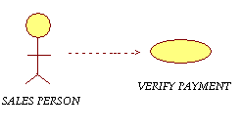
Precondition | To verify the payment the sales person must receive order from customer.
Post condition | Not applicable.
Basic flow | - Open the system  - Enter URL  - Enter username  - Enter password  - Clicks on “OK” button  - Clicks on verify payment
Input | - URL  - Username  - Password
Output | Send an acknowledgement to the customer as successfully verified.
Alternate Flows | Not applicable.
Special instructions | Not applicable.

Requirement ID | SC_SP_PB_10
Module Name | Sales person module
Use Case Name | PRINT IN-VOICE BILLS
Use Case Description | Here using the use case, the Sales person print in-voice bills and sends the receipt to the customer.
Primary Actor | SALES PERSON
Usecase Diagram | 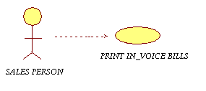
Precondition | Sales person must verify the payment which has been done by the customer.
Post condition | Sales person print in-voice bills to the verified payment and send receipt to the customer.
Basic flow | - Open the system  - Enter URL  - Enter Username  - Enter Password  - Clicks on ‘OK” button  - Clicks on RECEIVE ORDER  - Clicks on VERIFY PAYMENT  - Clicks on PRINT IN-VOICE BILLS
Input | - URL  - Username  - Password
Output | Page is opened to perform certain actions like receive order, verify payment, print in-voice bills, etc.,
Alternate Flows | Not applicable.
Special instructions | Not applicable.

Requirement ID | SC_SP_NW_11
Module Name | Sales person module
Use Case Name | NOTIFY WAREHOUSE ABOUT ORDER
Use Case Description | Here using the use case, the Sales person notifies warehouse about customer order.
Primary Actor | SALES PERSON
Usecase Diagram | 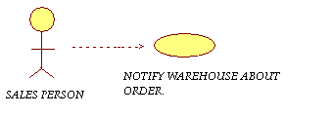
Precondition | Customer must place order to the sales person.
Post condition | Successfully updated.
Basic flow | - Open the system  - Enter URL  - Enter Username  - Enter Password  - Clicks on “OK” button  - View various links on the page  - Clicks on required link
Input | - URL  - Username  - Password
Output | Sales person clicks on notify warehouse about order i.e., inform warehouse about the order placed by the customer.
Alternate Flows | Not applicable.
Special instructions | Not applicable.

Requirement ID | SC_WHE_MNGP_12
Module Name | Warehouse employee module
Use Case Name | MANAGE PRODUCTS LIST ONLINE
Use Case Description | Here using the use case, the warehouse employee manages the products list online.
Primary Actor | WAREHOUSE EMPLOYEE
Usecase Diagram | 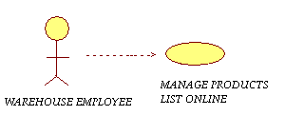
Precondition | - Shop must load new products to update information to the site  - To increase sales new offers must be implemented such as discounts, free coupons, etc.,
Post condition | Warehouse employees create, update and delete the latest information to the site.
Basic flow | - Login to the system.  - Warehouse employee updates the products information.  - View the list of existing products.  - Update the latest information.  - Exit from the page.  - Ware house employee delete the products information  - View the list of existing products.  - Delete the information  - Exit from the page.
Input | - URL  - Username  - Password
Output | Manage successfully.
Alternate Flows | Not applicable.
Special instructions | Not applicable

Requirement ID | SC_WHE_VR_13
Module Name | Warehouse module
Use Case Name | VIEW INFORMATION OF NEW REGISTRATIONS
Use Case Description | Here using the use case, the warehouse employee will manage the customer registration details.
Primary Actor | WAREHOUSE EMPLOYEE
Usecase Diagram | 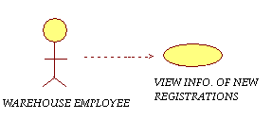
Precondition | Customers should be registered to the site.
Post condition | Not applicable.
Basic flow | - Enter URL  - Enter Username  - Enter Password  - Clicks on “OK” button  - Opens the page of various links  - Perform required operation
Input | - URL  - Username  - Password
Output | - Warehouse employee will get a screen about new registrations.  - Else no new registrations existing.
Alternate Flows | Not applicable.
Special instructions | Not applicable.

Requirement ID | SC_WHE_US_14
Module Name | Warehouse Module
Use Case Name | UPDATE ORDER STATUS
Use Case Description | Here using the use case, the warehouse employee can update the order status.
Primary Actor | WAREHOUSE EMPLOYEE
Usecase Diagram | 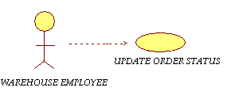
Precondition | - Customer must place an order.  - Order details must exist in the system.
Post condition | Update has been done successfully.
Basic flow | - Open the system  - Enter URL  - Enter Username  - Enter Password  - Clicks on “OK” button  - Opens the page of various links  - Perform required operation
Input | - URL  - Username  - Password
Output | Sales person updates information of the products and special offers which has to be implemented.
Alternate Flows | Not applicable.
Special instructions | Not applicable.

Requirement ID | SC_WHE_CS_15
Module Name | Warehouse Module
Use Case Name | CHECKS DELIVERY STATUS
Use Case Description | Here using the use case, the warehouse employee can check the delivery status.
Primary Actor | WAREHOUSE EMPLOYEE
Usecase Diagram | 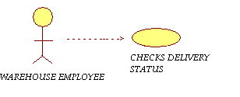
Precondition | Order must exist.
Post condition | Not applicable.
Basic flow | - Open the system  - Enter URL  - Enter Username  - Enter Password  - Clicks on “OK” button  - Opens the page of various links  - Perform required operation
Input | - URL  - Username  - Password
Output | Verifies the delivery status.
Alternate Flows | Not applicable.
Special instructions | Not applicable.

ACTIVITY DIAGRAM

ACTOR: CUSTOMER
USECASE: LOGIN

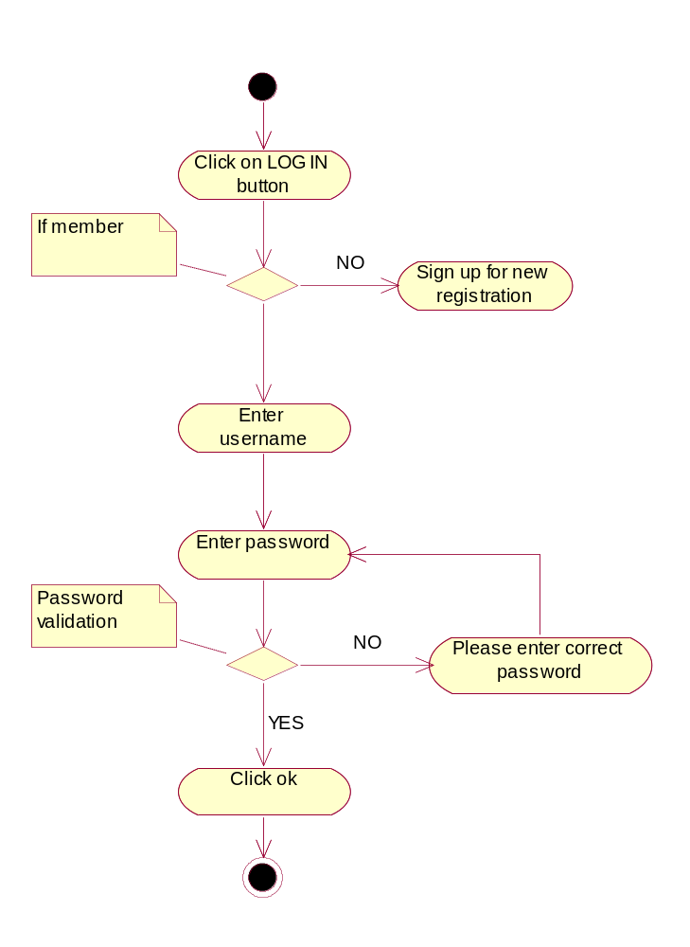

ACTOR: CUSTOMER, SALES PERSON, WAREHOUSE EMPLOYEE
USECASE: REGISTER
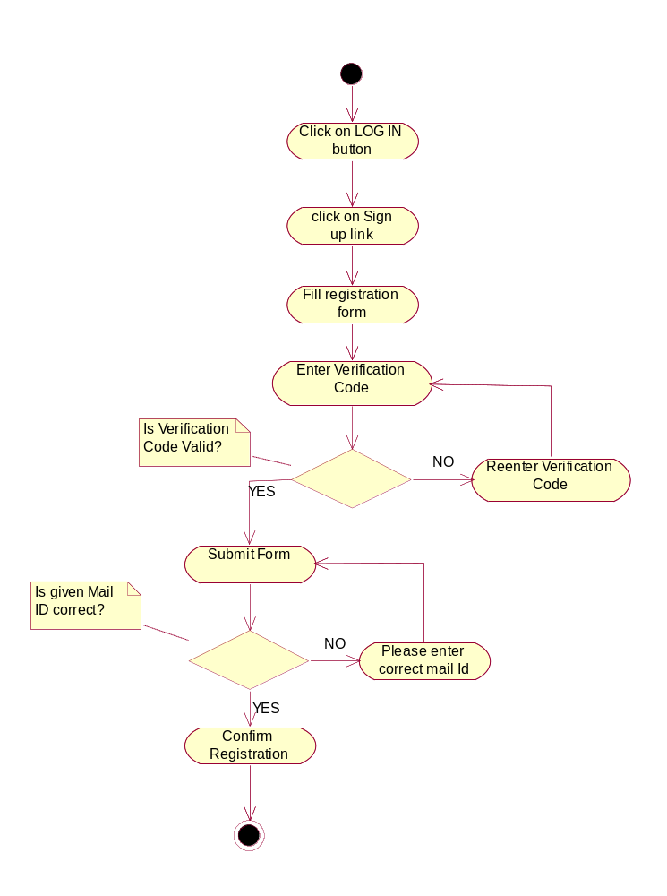

ACTOR: CUSTOMER
USECASE: VIEW THE PRODUCTS
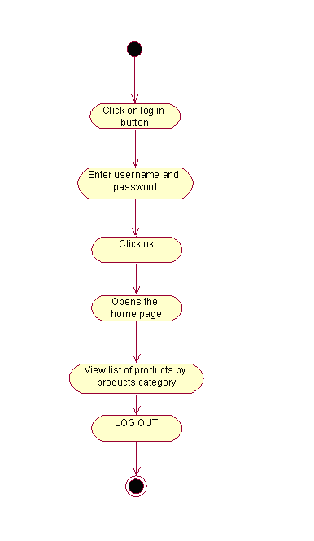

ACTOR: CUSTOMER
USECASE: PLACE ORDER
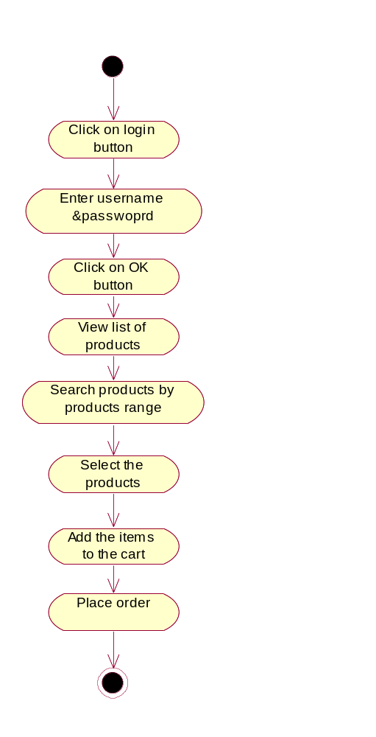

ACTOR: CUSTOMER
USECASE: MAKE PAYMENT
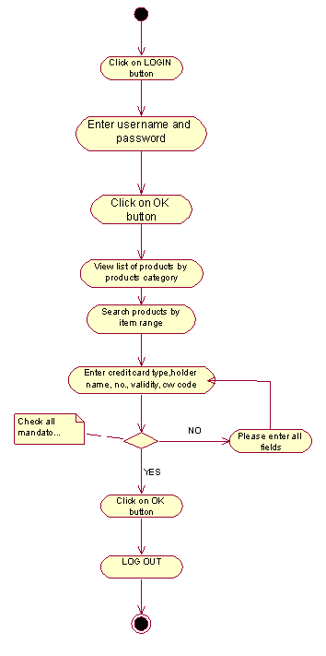

ACTOR: CUSTOMER
USECASE: CHANGE PROFILE

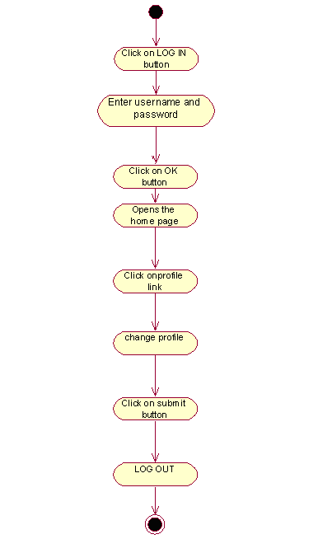

ACTOR: CUSTOMER, SALES PERSON, WAREHOUSE EMPLOYEE
USECASE: LOGOUT

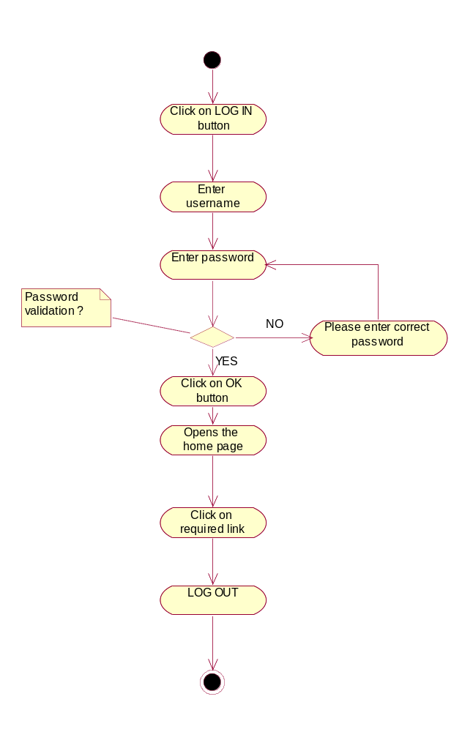

ACTOR: SALES PERSON
USECASE: RECEIVES ORDER

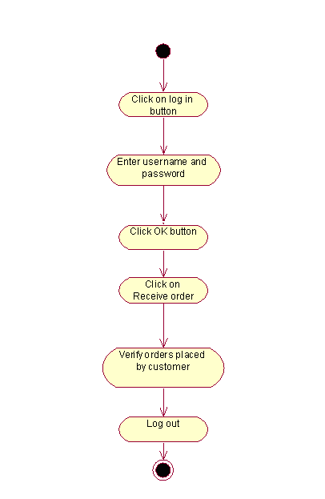

ACTOR: SALES PERSON
USECASE: VERIFY PAYMENT

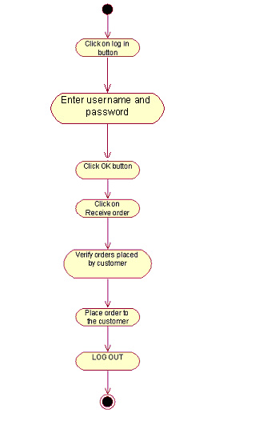

ACTOR: SALES PERSON
USECASE: PRINT INVOICE BILLS
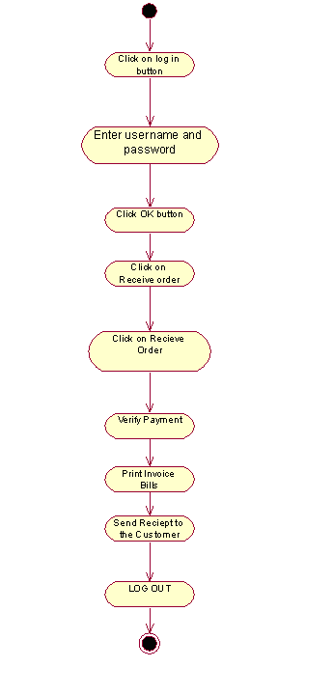

ACTOR: SALES PERSON
USECASE: NOTIFY WAREHOUSE ABOUT ORDER

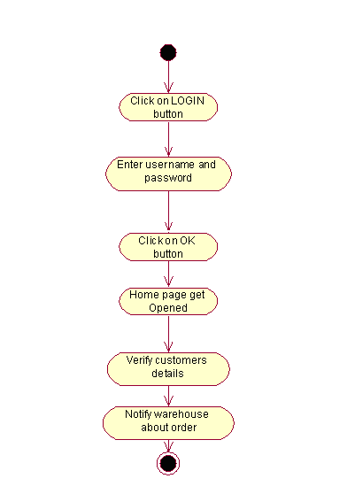

ACTOR: WAREHOUSE EMPLOYEE
USECASE: MANAGE PRODUCT LIST ONLINE

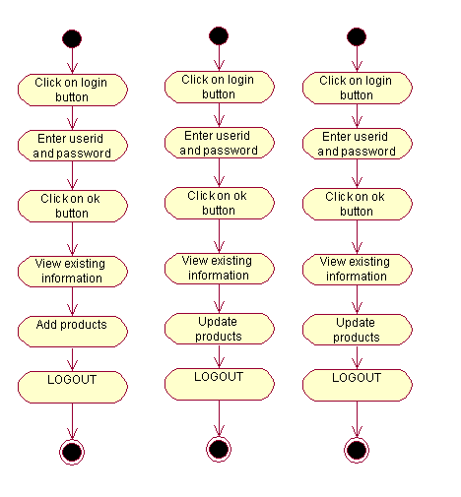

ACTOR: WAREHOUSE EMPLOYEE
USECASE: VIEW INFORMATION OF NEW REGISTRATIONS

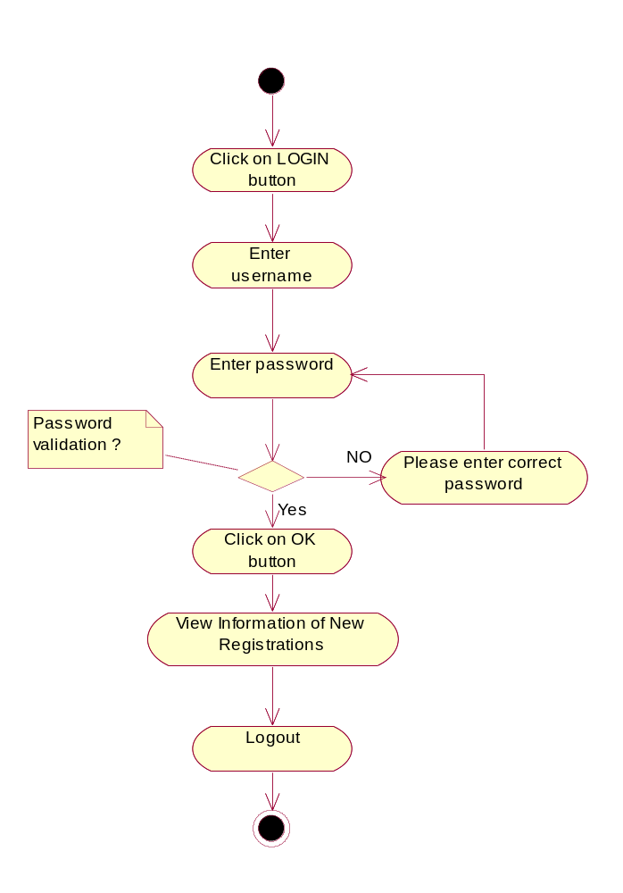

ACTOR: WAREHOUSE EMPLOYEE
USECASE: UPDATE ORDER STATUS
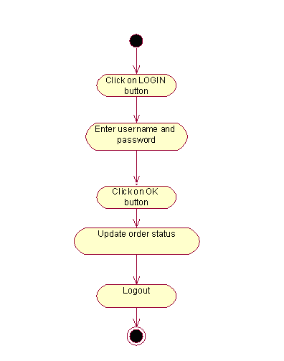

ACTOR: WAREHOUSE EMPLOYEE
USECASE: CHECK DELIVERY STATUS
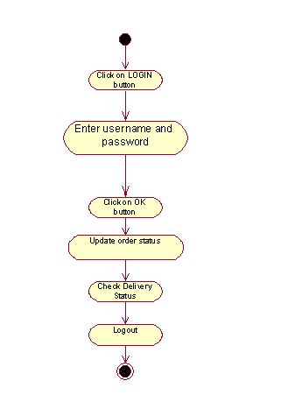

SYSTEM DESIGN

SYSTEM FEATURE & SEQUENCE DIAGRAM

System Feature _ID | SF_SC_CUST_01
Requirement_ID | SC_CUST_REG_01
Actor | Customer
Business logic | - Clicks on sign up button  - Display the page  - Fill the form  - Perform client side validation  - Send data for server to perform business operation  - Perform server side validation  - Establish database connection  - Returns connection message acknowledgement  - Execute SQL to insert customer details into customer table  - Returns customer details  - Display an acknowledgement for successful registration
Client side validations | Check for the entry of all fields
Server side validations | Check for validity of userid and password

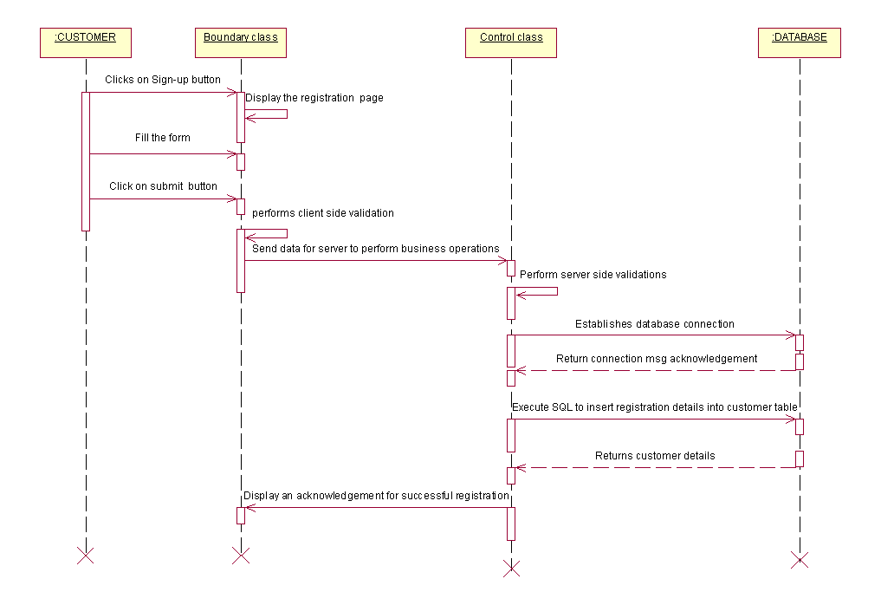
System Feature _ID | SF_SC_CUST_02
Requirement_ID | SC_CUST_LI_01
Actor | Customer
Business logic | - Clicks on login button  - Display login page  - Enter userid and password  - perform client side validation  - Send data for server to perform business operation  - Establishes database connection  - Returns connection message acknowledgement  - Check for validity of login credentials  - Display the home page
Client side validations | - Check for the entry of userid  - Check for the entry of password
Server side validations | Check for validity of userid and password

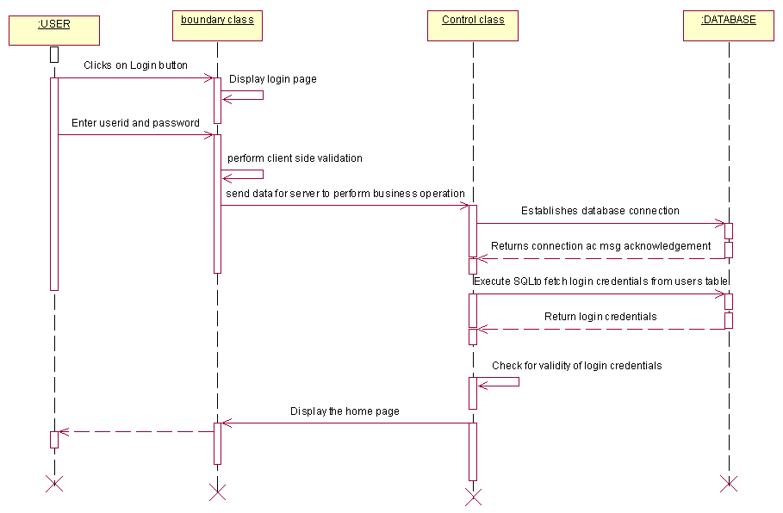

System Feature _ID | SF_SC_CUST_03
Requirement_ID | SC_CUST_VP_03
Actor | Customer
Business logic | - Click on view products  - Perform client side validation  - Send data for server to perform business operation  - Perform server side validation  - Establishes database connection  - Returns connection message acknowledgement  - Execute SQL to select product details from product table  - Returns products details  - Display the products page
Client side validations | - Check for the entry of userid  - Check for the entry of password
Server side validations | Check for validity of userid and password

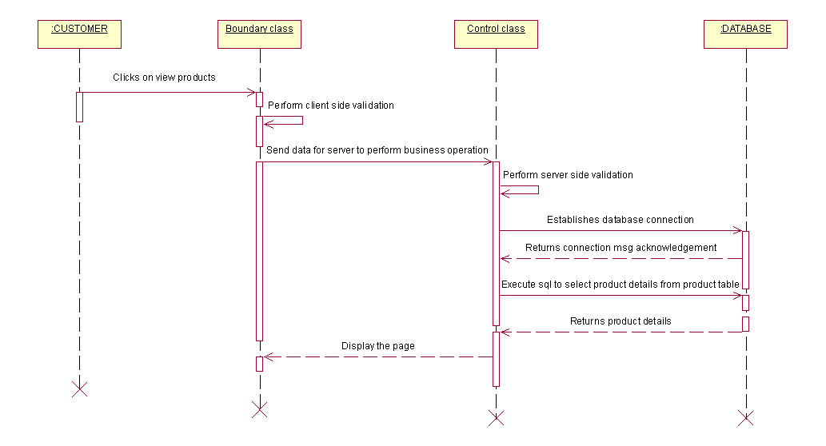

System Feature _ID | SF_SC_CUST_04
Requirement_ID | SC_CUST_PO_04
Actor | Customer
Business logic | - Select the products and add to cart  - Display the page to review the added products  - Click on submit button  - Send data for server to perform business operation  - Perform server side validation  - Check the availability of products  - Establishes database connection  - Returns the connection message acknowledgement  - Execute SQL to select products details from product table  - Returns products details  - Display the page
Client side validations | - Check for the entry of userid  - Check for the entry of password
Server side validations | - Check for validity of userid and password  - Check for the availability of products

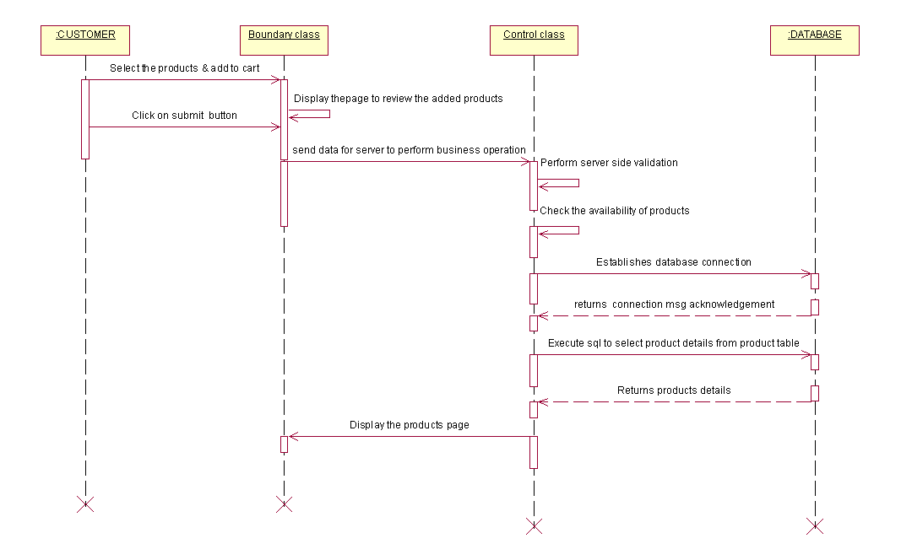

System Feature _ID | SF_SC_CUST_05
Requirement_ID | SC_CUST_MP_05
Actor | Customer
Business logic | - Click on make payment  - Display the payment page  - Enter all fields  - Click on submit button  - Perform client side validation  - Send data for server to perform business operation  - Perform server side validation  - Check the validity of card  - Establishes database connection  - Returns connection message acknowledgement  - Execute SQL to insert payment details into payment table  - Returns payment details  - Display the page for acknowledgement of successful payment
Client side validations | - Check for the entry of all fields  2. Check for the entry of correct card number
Server side validations | Check for the validity of card.

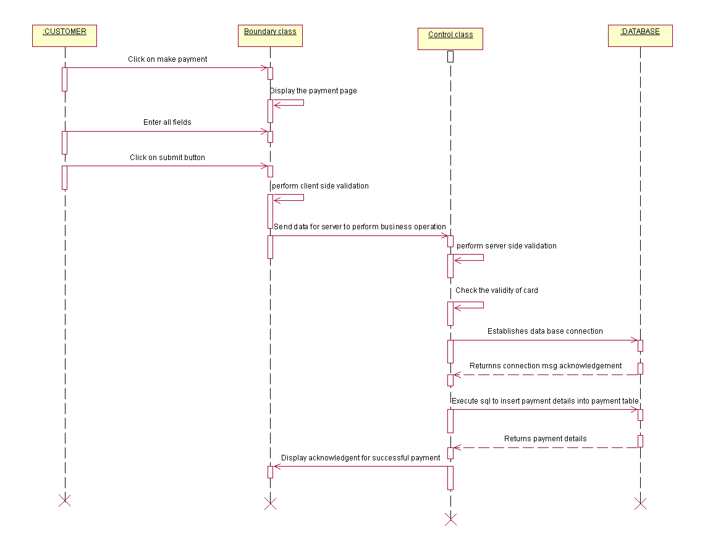

System Feature _ID | SF_SC_CUST_06
Requirement_ID | SC_CUST_CP_06
Actor | Customer
Business logic | - Click on change profile link  - Display profile page  - Change the details  - Click on submit button  - Perform client side validation  - Send data for server to perform business operation  - Perform server side validation  - Establishes database connection  - Returns connection message acknowledgement  - Execute SQL to insert customer details into customer table  - Returns customer details  - Display the page with latest details
Client side validations | - Check for the entry of userid and password  - Check for the entry of all fields
Server side validations | Check for the validity of userid and pasword

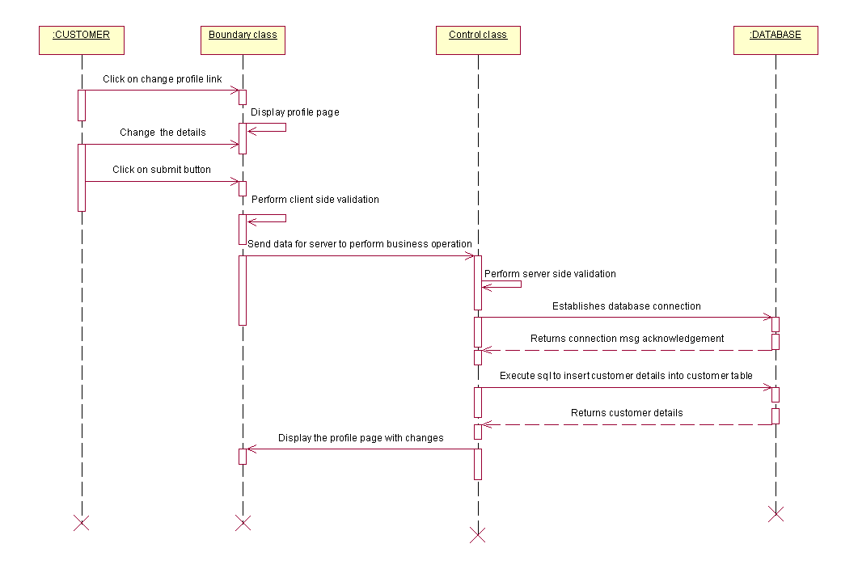

System Feature _ID | SF_SC_CUST_07
Requirement_ID | SC_CUST_LO_07
Actor | Customer
Business logic | - Click on logout button  - Perform client side validation  - Send data for server to perform business operation  - Perform server side validation  - Display the login page
Client side validations | Check for the entry of userid and password
Server side validations | Check for the validity of userid and password

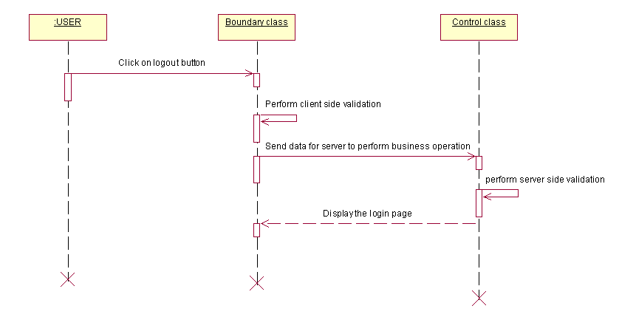

System Feature _ID | SF_SC_SP_08
Requirement_ID | SC_SP_RO_08
Actor | Sales person
Business logic | - Click on order details  - Perform client side validation  - Send data for server to perform business operation  - Perform server side validation  - Establishes database connection  - Returns connection message acknowledgement  - Execute SQL to fetch order details from order table  - Returns order details  - Display the order details page
Client side validations | Check for the entry of userid and password
Server side validations | Check for the validity of userid and password

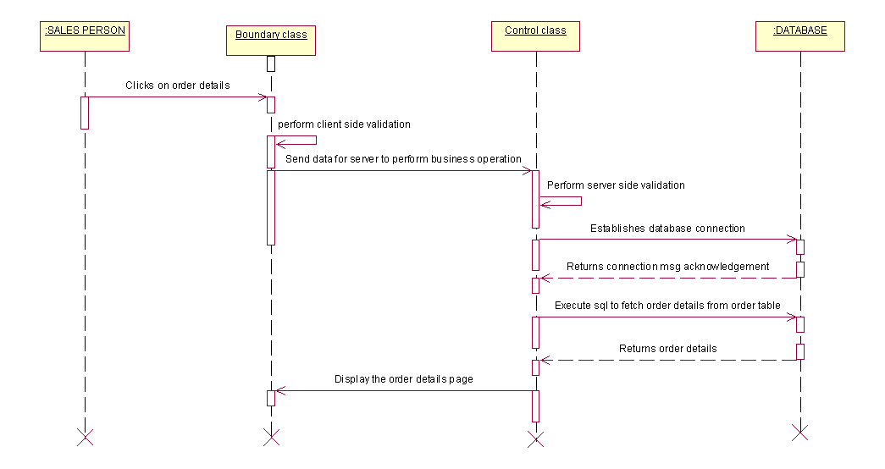

System Feature _ID | SF_SC_SP_09
Requirement_ID | SC_SP_VP_09
Actor | Sales person
Business logic | - Click on payment details  - Perform client side validation  - Send data for server to perform business operation  - Perform server side validation  - Establishes database connection  - Returns connection message acknowledgement  - Execute SQL to fetch payment details from payment table  - Returns payment details  - Display the page to verify the details
Client side validations | Check for the entry of userid and password
Server side validations | Check for the validity of userid and password

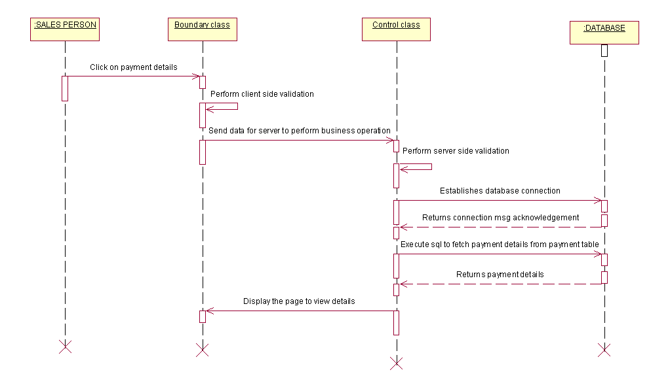

System Feature _ID | SF_SC_SP_10
Requirement_ID | SC_SP_PB_10
Actor | Sales person
Business logic | - Click on billing  - Display the page  - Print-In-Voice bills  - Product is packed to the customer  - Perform client side validation  - Send data for server to perform business operation  - Perform server side validation  - Establishes database connection  - Returns connection message acknowledgement  - Execute SQL to fetch customer details from customer table  - Returns customer details  - Display the page to delivery the product
Client side validations | Check for the entry of userid and password
Server side validations | Check for the validity of userid and password

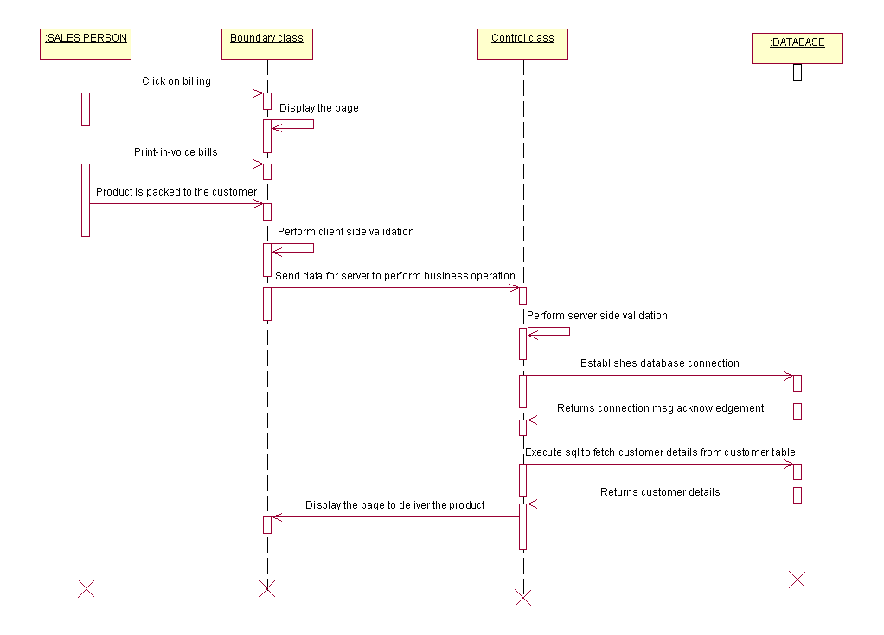

System Feature _ID | SF_SC_SP_11
Requirement_ID | SC_SP_NO_11
Actor | Sales person
Business logic | - Notifies warehouse about order  - Performs client side validation  - Send data for server to perform business operation  - Performs server side validation  - Establishes database connection  - Returns connection message acknowledgement  - Execute SQL to fetch order details from order table  - Returns order table  - Display the acknowledgement for successful updations
Client side validations | Check for the entry of userid and password
Server side validations | Check for the validity of userid and password

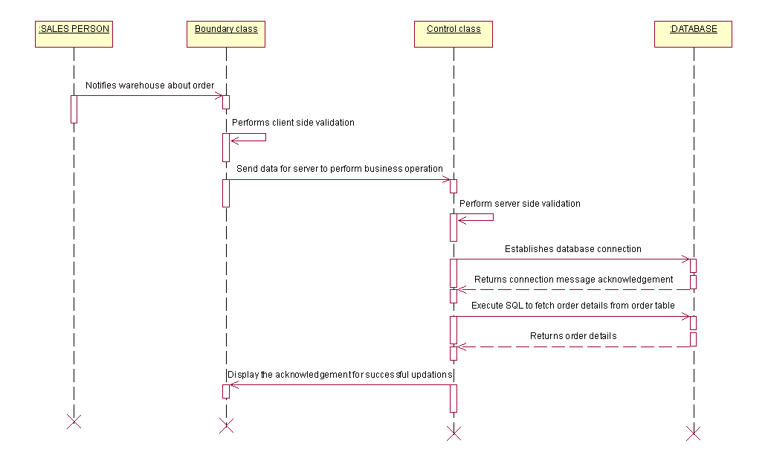

System Feature _ID | SF_SC_WHE_12
Requirement_ID | SC_SP_NR_12
Actor | Warehouse Employee
Business logic | - Click on registrations  - Display the page  - Perform client side validation  - Send data for server to perform business operation  - Perform server side validation  - Establishes database connection  - Returns connection message acknowledgement  - Execute SQL to select customer details from customer table  - Returns customer table  - Display the page to view new registration table
Client side validations | Check for the entry of userid and password
Server side validations | Check for the validity of userid and password

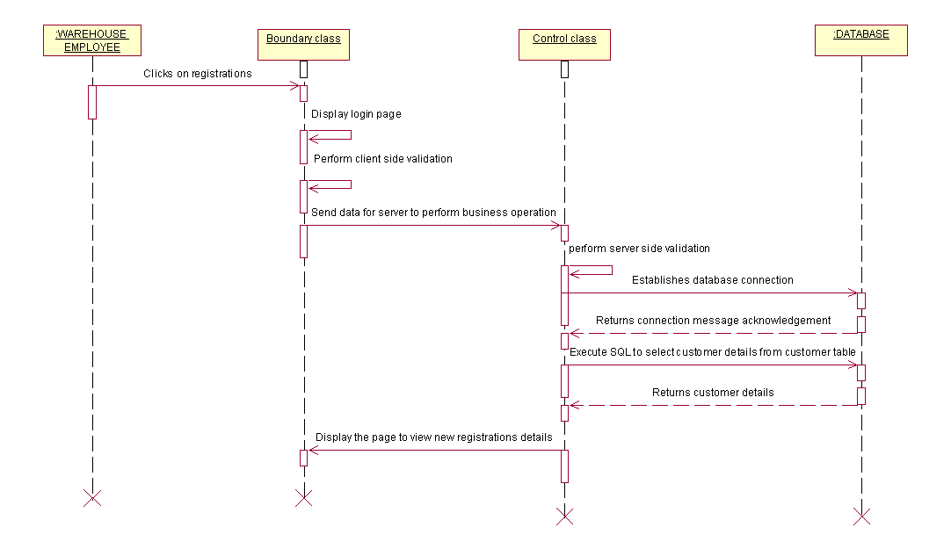

System Feature _ID | SF_SC_WHE_13
Requirement_ID | SC_SP_MNGP_13
Actor | Warehouse Employee
Business logic | - Click on manage products  - Display the page  - Add/Delete/Update the products  - Perform client side validation  - Send data for server to perform business operation  - Perform server side validations  - Establishes database connection  - Returns connection message acknowledgement  - Execute SQL to insert/delete/select products details from product table  - Returns product table  - Display the page with latest updates
Client side validations | Check for the entry of userid and password
Server side validations | Check for the validity of userid and password

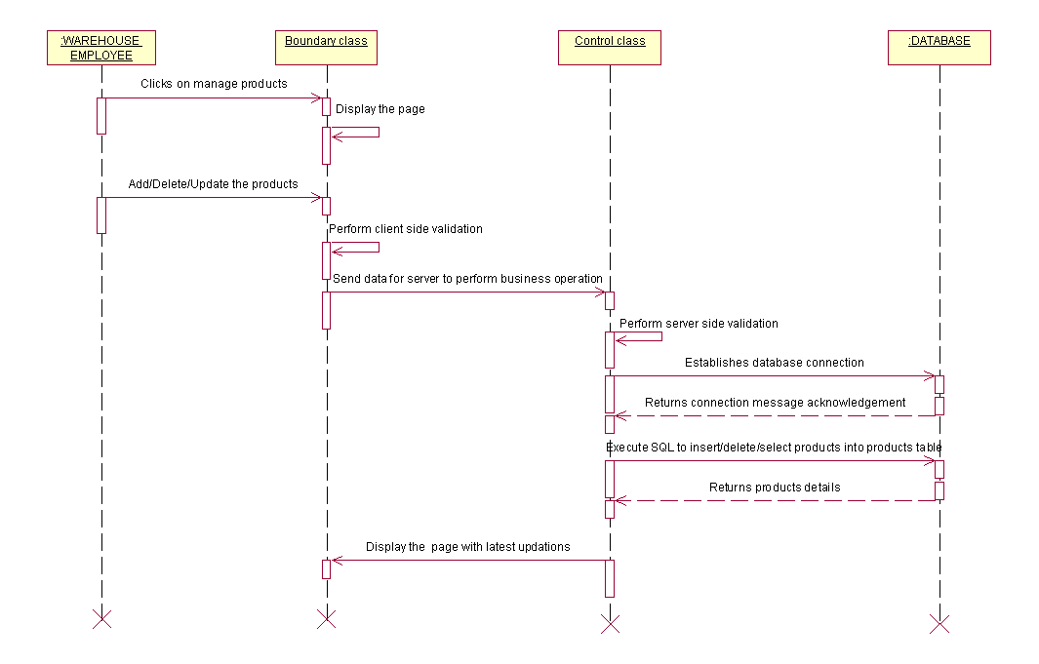

System Feature _ID | SF_SC_WHE_14
Requirement_ID | SC_SP_US_14
Actor | Warehouse Employee
Business logic | - Click on status  - Display the page  - Update order status online  - Perform client side validation  - Send data for serer to perform business operation  - Perform server side validation  - Establishes database connection  - Returns connection message acknowledgement  - Execute SQL to insert status details into online status table  - Returns online status details  - Display the acknowledgement for successful updates
Client side validations | Check for the entry of userid and password
Server side validations | Check for the validity of userid and password

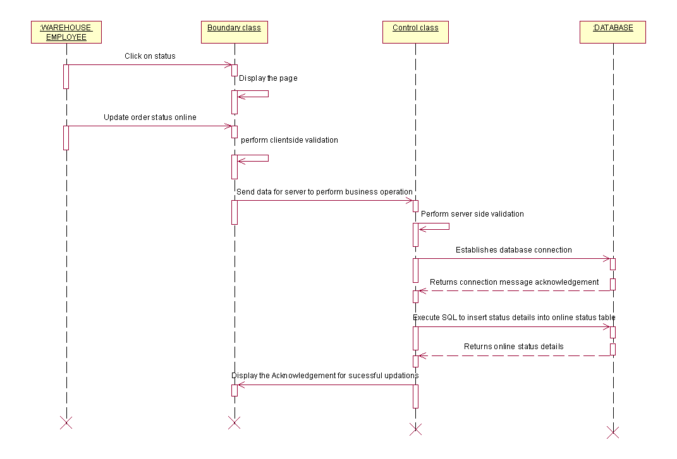

System Feature _ID | SF_SC_WHE_15
Requirement_ID | SC_SP_CS_15
Actor | Warehouse Employee
Business logic | - Click on status  - Perform client side validation  - Send data for server to perform business operation  - Perform server side validation  - Establishes database connection  - Returns connection message acknowledgement  - Execute SQL to select status details from online status table  - Returns online status details  - Display the page to view details
Client side validations | Check for the entry of userid and password
Server side validations | Check for the validity of userid and password

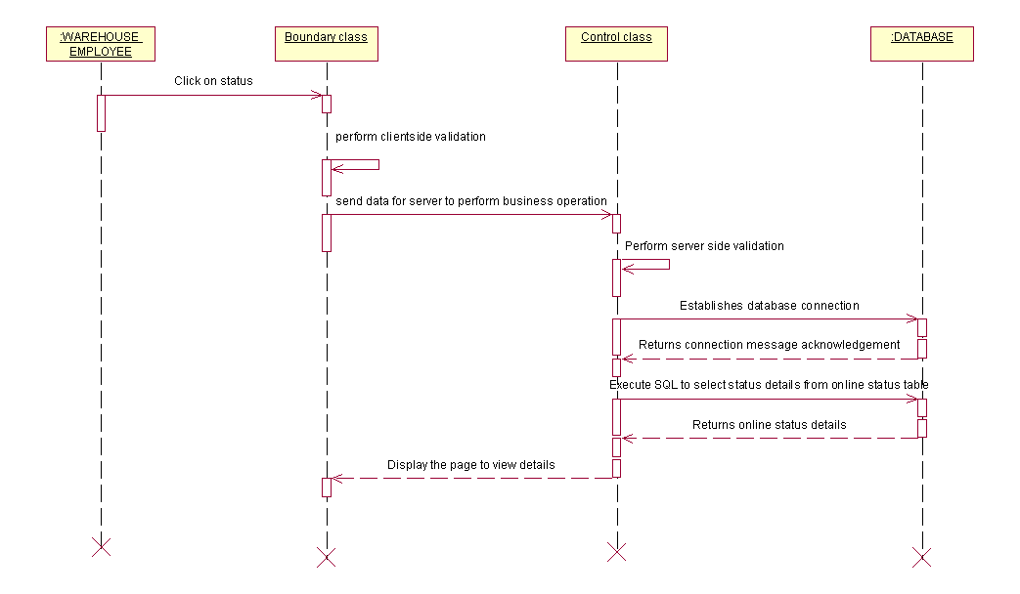

COLLABORATION DIAGRAM

USECASE: REGISTER

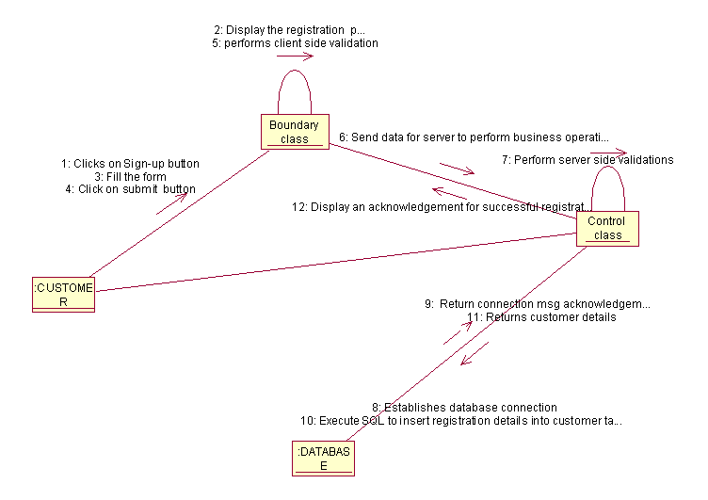

USECASE: LOGIN

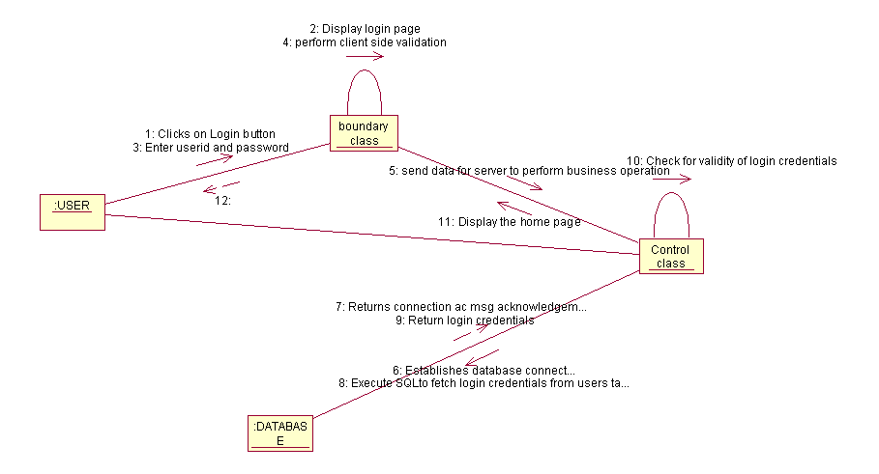
USECASE: VIEW THE PRODUCTS

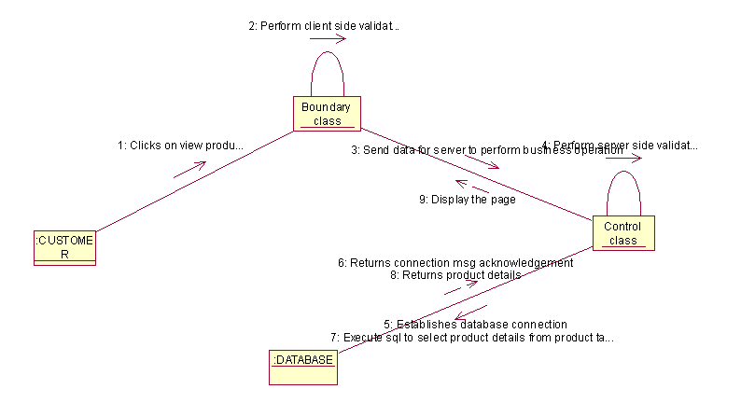

USECASE: PLACE ORDER

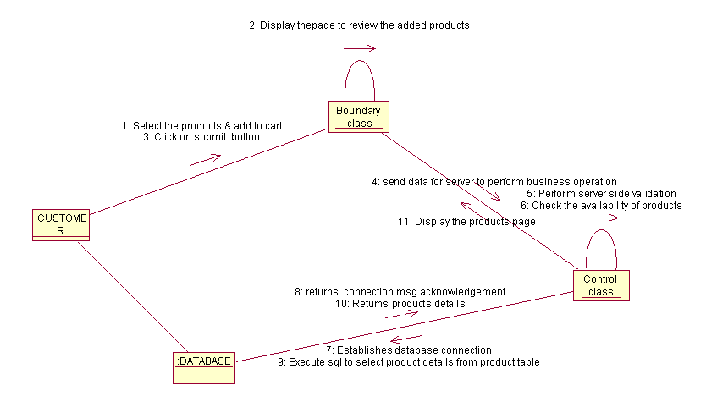

USECASE: MAKE PAYMENT

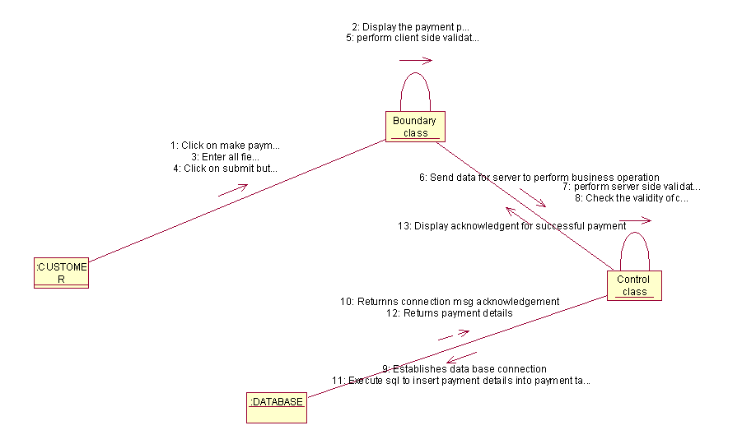

USECASE: CHANGE PROFILE

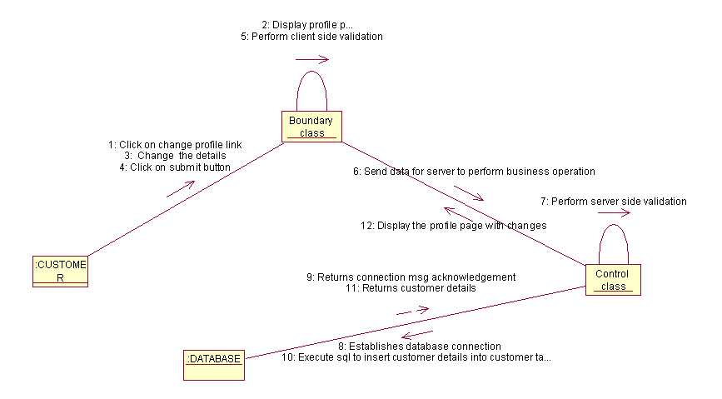

USECASE: LOGOUT

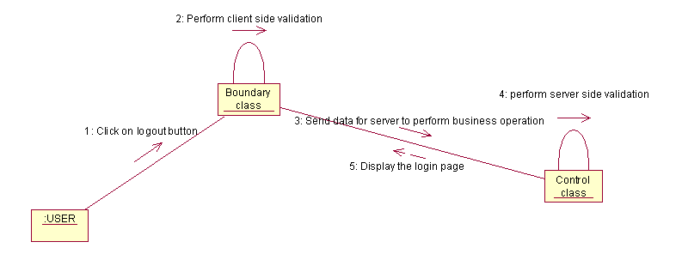

USECASE: RECEIVES ORDER

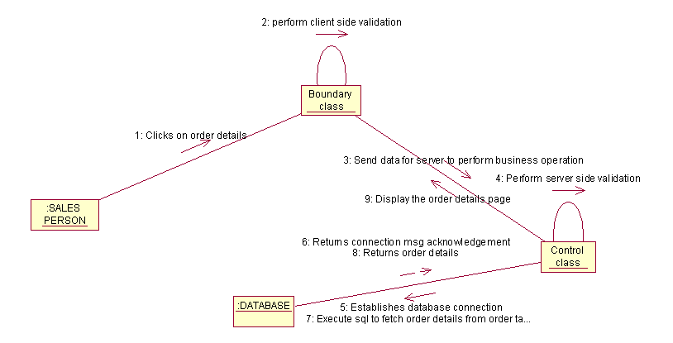

USECASE: VERIFY PAYMENT

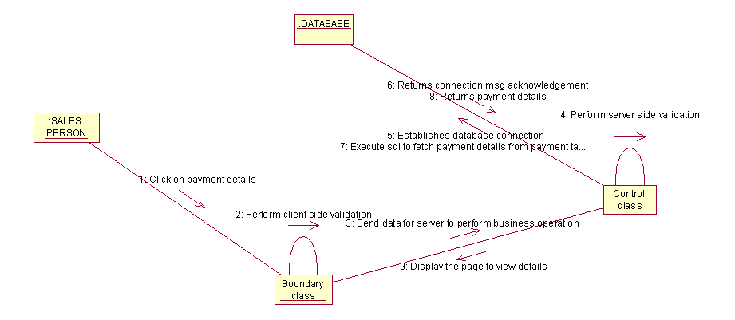

USECASE: PRINT-IN-VOICE BILLS

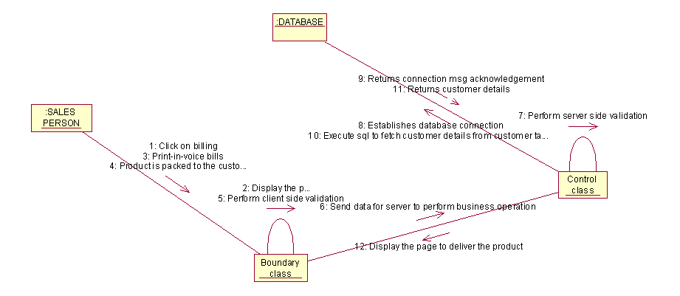

USECASE: NOTIFY WAREHOUSE ABOUT ORDER

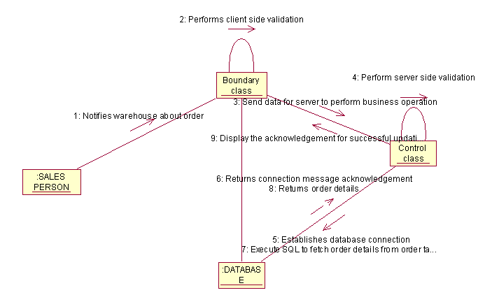

USECASE: VIEW INFORMATION OF NEW REGISTRATIONS

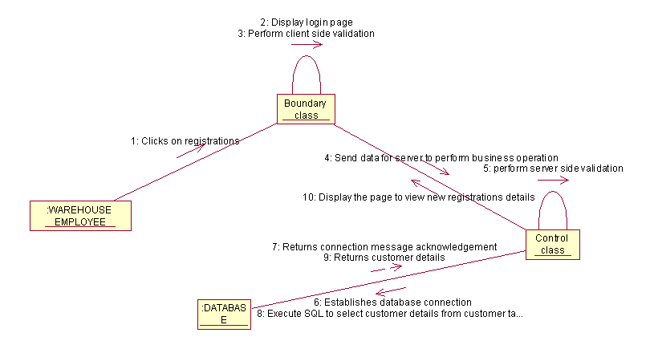
USECASE: MANAGE PRODUCTS

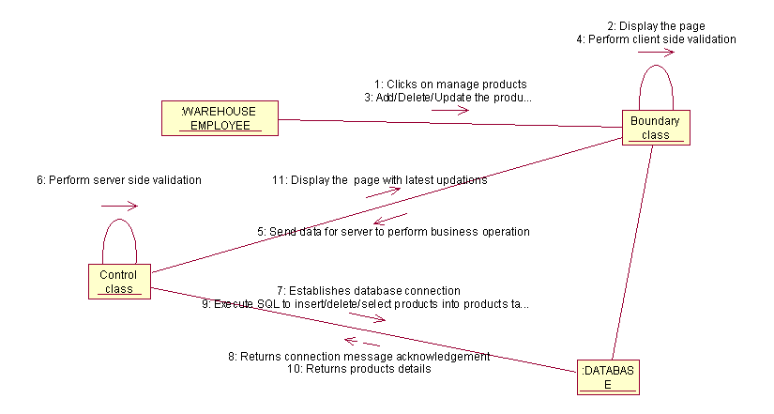

USECASE: UPDATE ORDER STATUS

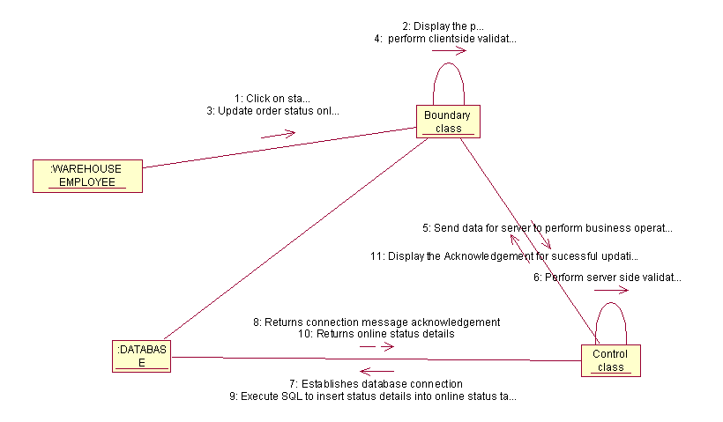

USECASE: CHECK DELIVERY STATUS

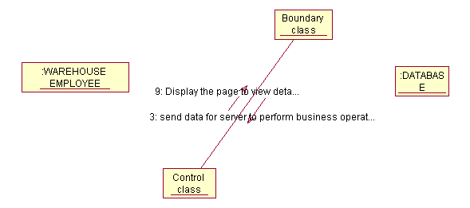

DATA DICTIONARY

ER DIAGRAM

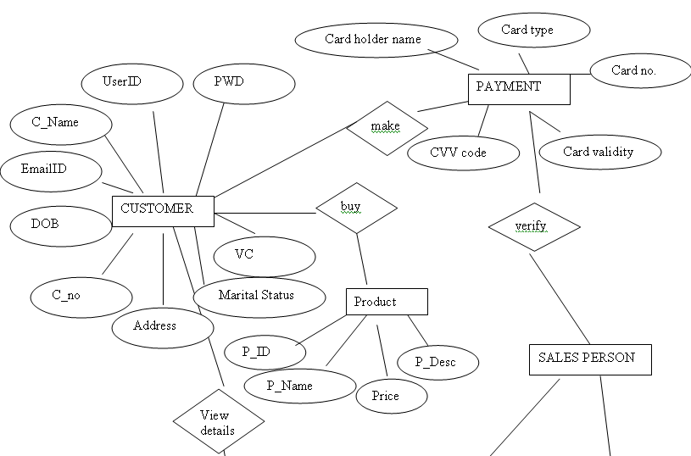
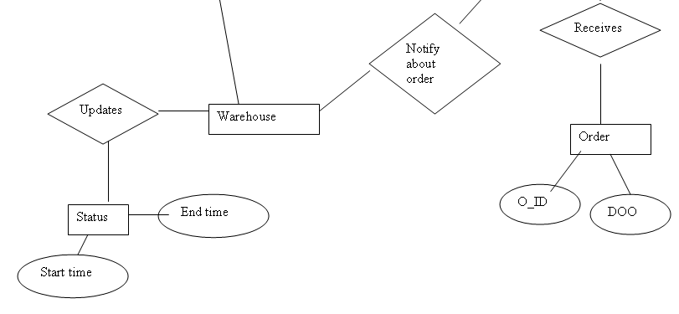

TABLE STRUCTURE

USERS TABLE

Column name | Data type | size | Allow nulls | Constraints | Remarks
Username | varchar | 50 | true | Foreign key
Password | varchar | 50 | true
Role | varchar | 50 | true

CUSTOMER TABLE

Column name | Data type | size | Allow nulls | Constraints | Remarks
Username | varchar | 50 | false | Primary key
Password | varchar | 50 | true
C_Name | varchar | 50 | true
DOB | datetime |  | true
Marital status | char | 10 | true
Contact no. | Int |  | true
Email_id | varchar | 50 | true
Postal address | Varchar | 50 | True
Verification code | varchar | 50 | True

PRODUCTS TABLE

Column name | Data type | size | Allow nulls | Constraints | Remarks
P_ID | varchar | 50 | False | Primary key
P_Name | varchar | 50 | True
price | decimal | (18,0) | True
P_Desc | Varchar | 50 | True

ORDER TABLE

Column name | Data type | size | Allow nulls | Constraints | Remarks
O_ID | varchar | 50 | False | Primary key
P_ID | varchar | 50 | true | Foreign key
P_Name | varchar | 50 | True
Price | decimal | (18,0) | True

PAYMENT TABLE

Column name | Data type | size | Allow nulls | Constraints | Remarks
Card Holder name | varchar | 50 | False | Primary key
C_Name | varchar | 50 | true | Foreign key
Card type | varchar | 50 | True
Card no. | decimal | (18,0) | True
Card Validity | datetime |  | True
Cvv code | varchar | 50 | True

ONLINE STATUS TABLE

Column name | Data type | Size | Allow nulls | Constraints | Remarks
User Name | varchar | 50 | true | Foreign key
P_ID | varchar | 50 | true | Foreign key
O_ID | varchar | 50 | true | Foreign key
Start time | datetime |  | true
End time | datetime |  | true

CLASS DIAGRAM

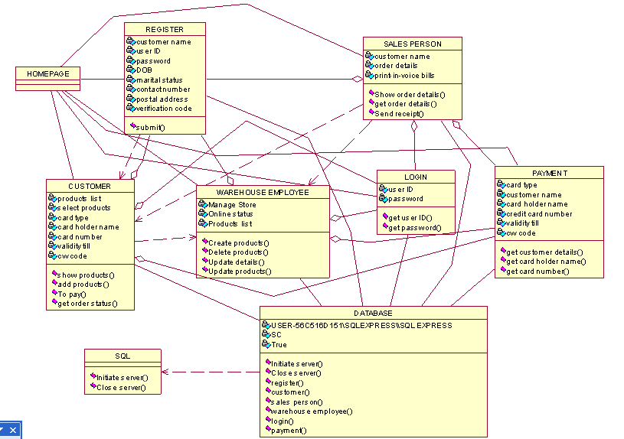

USER INTERFACE DESIGN

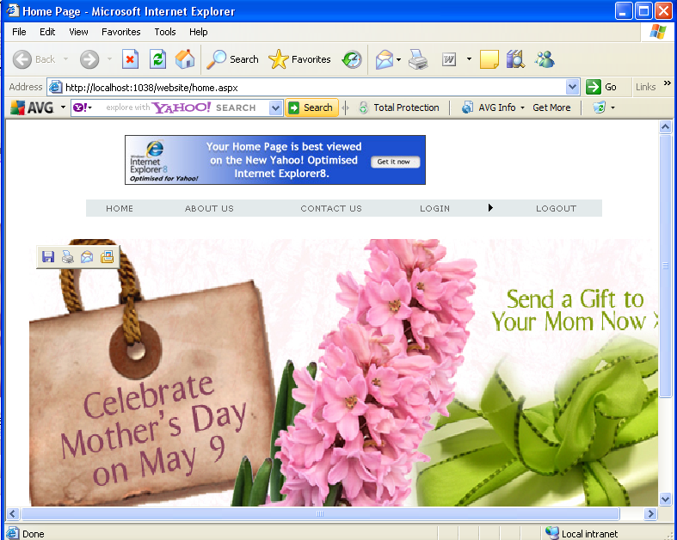

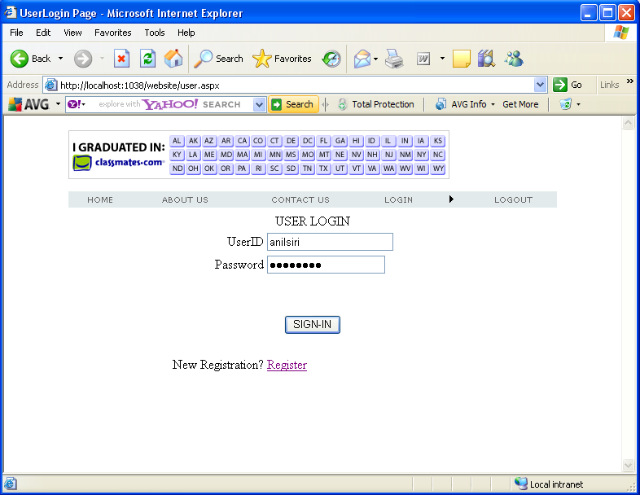

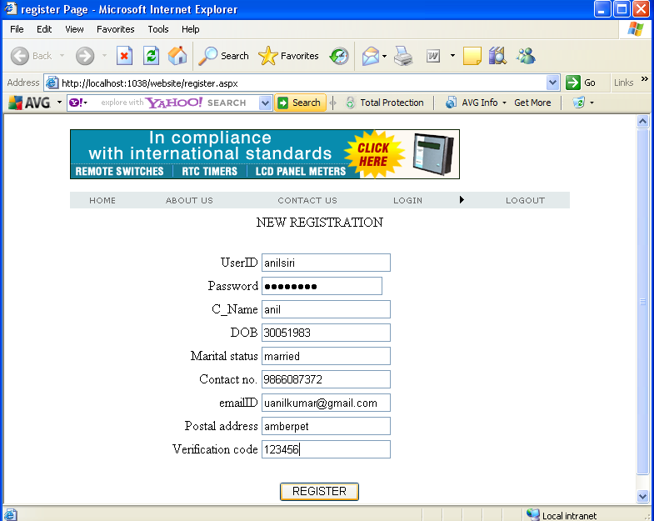

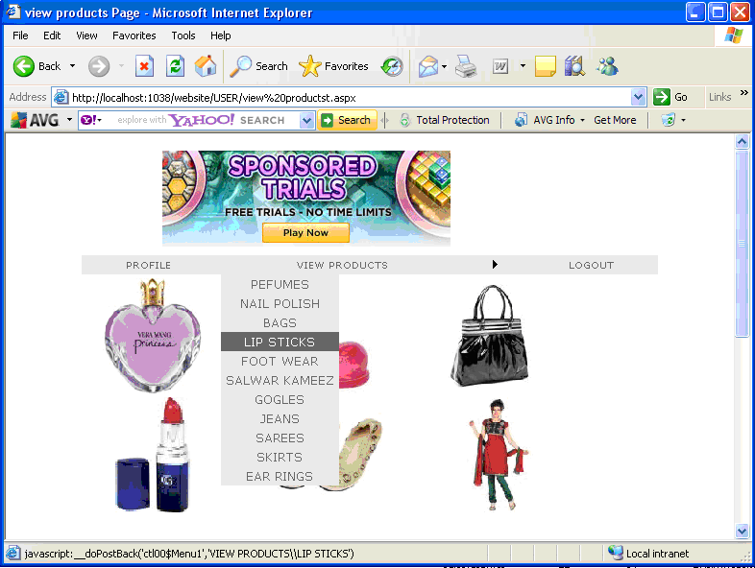

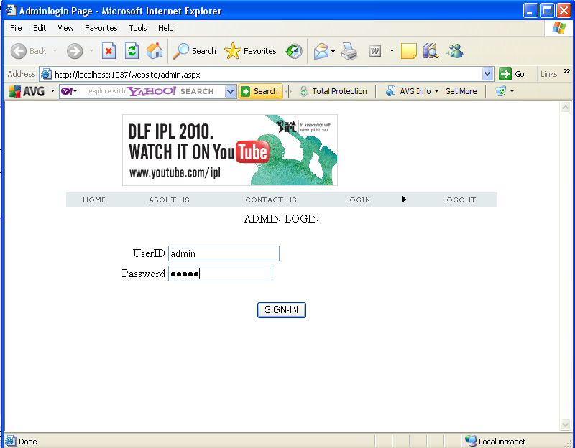

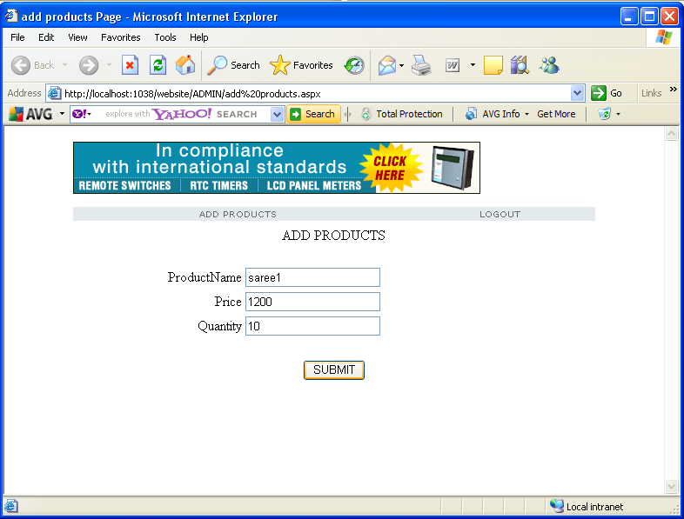

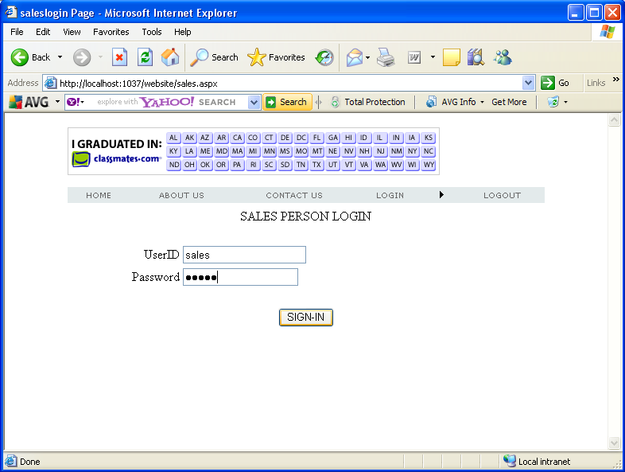

- CODING

CODING STANDARDS AND GUIDELINES
TECHNOLOGY NOTES

.NET FRAMEWORK (FRONT END)

The Microsoft.NET strategy was presented by Microsoft officials to the rest of the world in June 2000:

- .NET is Microsoft's new Internet and Web strategy
- .NET is NOT a new operating system
- .NET is a new Internet and Web based infrastructure
- .NET delivers software as Web Services
- .NET is a framework for universal services
- .NET is a server centric computing model
- .NET will run in any browser on any platform
- .NET is based on the newest Web standards

.NET Internet Standards

.NET is built on the following Internet standards:

- HTTP, the communication protocol between Internet Applications
- XML, the format for exchanging data between Internet Applications
- SOAP, the standard format for requesting Web Services
- UDDI, the standard to search and discover Web Services

.NET Framework

- The .NET Framework is the infrastructure for the new Microsoft .NET Platform.

- The .NET Framework is a common environment for building, deploying, and running Web Services and Web Applications.

- The .NET Framework contains common class libraries - like ADO.NET, ASP.NET and Windows Forms - to provide advanced standard services that can be integrated into a variety of computer systems.

- The .NET Framework is language neutral. Currently it supports C++, C#, Visual Basic, and JScript (The Microsoft version of JavaScript). Third-party languages like COBOL, Eiffel, Perl, Python, Smalltalk, and others - will also be available for building future .NET Framework applications. The new Visual Studio.NET is a common development environment for the new .NET Framework. It provides a feature-rich application execution environment, simplified development and easy integration between a numbers of different development languages.

Common Language Runtime (CLR)

- The common language runtime is the execution engine for .NET Framework applications.
- It provides a number of services, including the following:
- Code management (loading and execution)
- Application memory isolation
- Verification of type safety
- Conversion of IL to native code
- Access to metadata (enhanced type information)
- Managing memory for managed objects
- Enforcement of code access security
- Exception handling, including cross-language exceptions
- Interoperation between managed code, COM objects, and pre-existing DLLs (unmanaged code and data)
- Automation of object layout
- Support for developer services (profiling, debugging, and so on)

Common Type System (CTS)

The common type system is a rich type system, built into the common language runtime that supports the types and operations found in most programming languages. The common type system supports the complete implementation of a wide range of programming languages.

Common Language Specification (CLS)
The Common Language Specification is a set of constructs and constraints that serves as a guide for library writers and compiler writers. It allows libraries to be fully usable from any language supporting the CLS, and for those languages to integrate with each other. The Common Language Specification is a subset of the common type system. The Common Language Specification is also important to application developers who are writing code that will be used by other developers. When developers design publicly accessible APIs following the rules of the CLS, those APIs are easily used from all other programming languages that target the common language runtime.

Microsoft Intermediate Language (MSIL)

MSIL is the CPU-independent instruction set into which .NET Framework programs are compiled. It contains instructions for loading, storing, initializing, and calling methods on objects.

Combined with metadata and the common type system, MSIL allows for true cross-language integration.
Prior to execution, MSIL is converted to machine code. It is not interpreted.

Assembly

An assembly is the primary building block of a .NET Framework application. It is a collection of functionality that is built, versioned, and deployed as a single implementation unit (as one or more files). All managed types and resources are marked either as accessible only within their implementation unit or as accessible by code outside that unit.
Assemblies are self-describing by means of their manifest, which is an integral part of every assembly. The manifest:
Establishes the assembly identity (in the form of a text name), version, culture, and digital signature (if the assembly is to be shared across applications).
Defines what files (by name and file hash) make up the assembly implementation. Specifies the types and resources that make up the assembly, including which are exported from the assembly.
Itemizes the compile-time dependencies on other assemblies.
Specifies the set of permissions required for the assembly to run properly.
This information is used at run time to resolve references, enforce version binding policy, and validate the integrity of loaded assemblies. The runtime can determine and locate the assembly for any running object, since every type is loaded in the context of an assembly. Assemblies are also the unit at which code access security permissions are applied. The identity evidence for each assembly is considered separately when determining what permissions to grant the code it contains.
The self-describing nature of assemblies also helps makes zero-impact install and XCOPY deployment feasible.

Options are available to deploy my .NET applications

The .NET Framework simplifies deployment by making zero-impact install and XCOPY deployment of applications feasible. Because all requests are resolved first to the private application directory, simply copying an application's directory files to disk is all that is needed to run the application. No registration is required.

This scenario is particularly compelling for Web applications, Web Services, and self-contained desktop applications. However, there are scenarios where XCOPY is not sufficient as a distribution mechanism. An example is when the application has little private code and relies on the availability of shared assemblies, or when the application is not locally installed (but rather downloaded on demand). For these cases, the .NET Framework provides extensive code download services and integration with the Windows Installer. The code download support provided by the .NET Framework offers several advantages over current platforms, including incremental download, code access security (no more Authenticode dialogs), and application isolation (code downloaded on behalf of one application doesn't affect other applications). The Windows Installer is another powerful deployment mechanism available to .NET applications. All of the features of Windows Installer, including publishing, advertisement, and application repair will be available to .NET applications in Windows Installer 2.0.

Garbage collection
Garbage collection is a mechanism that allows the computer to detect when an object can no longer be accessed. It then automatically releases the memory used by that object (as well as calling a clean-up routine, called a "finalize," which is written by the user). Some garbage collectors like the one used by .NET, compact memory and therefore decrease your program's working set.

COM objects from a .NET Framework
Yes. Any COM component you have deployed today can be used from managed code, and in common cases the adaptation is totally automatic.

Specifically, COM components are accessed from the .NET Framework by use of a runtime callable wrapper (RCW). This wrapper turns the COM interfaces exposed by the COM component into .NET Framework-compatible interfaces. For OLE automation interfaces, the RCW can be generated automatically from a type library. For non-OLE automation interfaces, a developer may write a custom RCW and manually map the types exposed by the COM interface to .NET Framework-compatible types.

Active Server Pages - ASP.NET

ASP.NET is the latest version of ASP. It includes Web Services to link
Applications , services and devices using HTTP, HTML, XML and SOAP.

New in ASP.NET:

- New Language Support
- Programmable Controls
- Event Driven Programming
- XML Based Components
- User Authentication
- User Accounts and Roles
- High Scalability
- Compiled Code
- Easy Configuration
- Easy Deployment
- Not ASP Compatible
- Includes ADO.NET

You can read more about ASP.NET and ADO.NET in our ASP.NET Tutorial.
Visual Studio.NET

The latest version of Visual Studio - Visual Studio.NET - incorporates ASP.NET,
ADO.NET, Web Services, Web Forms, and language innovations for Visual Basic. The
development tools have deep XML support, an XML-based programming model and new
Object-oriented programming capabilities.

Visual Basic.NET
Visual Basic.NET has added language enhancements, making it a full
Object-oriented programming language.

SQL Server 2000
SQL Server 2000 is a fully web-enabled database.
SQL Server 2000 has strong support for XML and HTTP which are two of the main infrastructure technologies for .NET.
Some of the most important new SQL Server features are direct access to the
Database from a browser, query of relational data with results returned as XML,
As well as storage of XML in relational formats.

Internet Information Server 6.0
IIS 6.0 has strong support for more programming to take place on the server, to
Allow the new Web Applications to run in any browser on any platform.

.NET Web Services:
Web services are small units of code built to handle a limited task.

What are Web Services?
- Web services are small units of code
- Web services are designed to handle a limited set of tasks
- Web services uses XML based communicating protocols
- Web services are independent of operating systems
- Web services are independent of programming languages
- Web services connect people, systems and devices

Small Units of Code
Web services are small units of code designed to handle a limited set of tasks.
An example of a web service can be a small program designed to supply other
applications with the latest stock exchange prices. Another example can be a
Small program designed to handle credit card payment.

SQL SERVER (BACK END)

Editions of SQL server

• Enterprise (Developer)

• Standard

• Personal

Components

• Server Components

• Components

Server Components

• SQL Server Engine

• SQL Server Agent

• Distributed Transaction Coordinator (DTC)

• Microsoft Search Engine

• SQL Mail

• English Query

• Data Transformation Services (DTS)

• Analysis Services

SQL Server Engine

• The core of SQL Server.

• It is the process that handles all the relational database work.

• SQL language describes engine only the query to be processed.

• Query optimizer determines how to process the query based on the costs of different types of query execution operations.

SQL Server Agent

• It is an optional process which, when running, executes the SQL jobs and handles other automated tasks.

Distributed Transaction Coordinator (DTC)

• It is a process that handles dual phase commits for transactions that span multiple SQL Servers.

Data Transformation Services (DTS)

• It moves data among nearly any types of data sources.

• DTS is extremely useful during data conversions, collecting data from many dissimilar data sources, or gathering for data warehousing.

• Analysis Services

• It enables the developer to define cubes that are similar to excel pivot tables or Access cross tab queries.

Client Components

• Server Network Utility

• Client Network Utility

• SQL Server Service Manager

• Enterprise Manager

• Query Analyzer

• Etc

Server Network Utility

• It configures the way in which SQL Server communicates with clients.

• Technically this is a client component used to control the server.

Client Network Utility

• It is the client side partner to the Server Network Utility.

• It establishes the protocols used to communicate from the client to server.

Service Manager

• A client utility to start and stop the major services of SQL Server and to indicate the current status.

Enterprise Manager

• It is used for administrative tasks.

• An interface for database diagrams.

Query Analyzer

• The tool for executing raw batches of T-SQL code.

• Editing, executing and saving scripts of code is what Query Analyzer does best.

• Also in viewing query-optimization plans and execution statistics.

Aggregate Functions
• Sum ()
• Avg ()
• Min ()
• Max ()
• Count ()
• Count Big () – Can Handle bigint datatype values.

Clauses
• Group By
• Having
• Order By

Joins
• A join merges rows from one data set with rows from another data set, and creates a new set of rows that includes columns from both.
Join Types
• Inner Join
• Left Outer Join
• Right Outer Join
• Full Outer Join
• Cross Join
• Theta Join

Inner Joins
• The inner join includes only those rows from each side of the join that are contained within the intersection of the two data sources.
Outer Joins
• An outer join includes not only rows from the two data sources with a match but also unmatched rows from outside the intersection.
Full Outer Join
• The full outer join returns all the data from both data sets,matching the rows where it can and filling in the holes with nulls.
Joins
• Self Join:-
A self join is a join that refers back to the same table.
• Cross Join:-
The cross join also called an unrestricted join is a pure relational algebra multiplication of the two source tables.
• Theta Join:-
These joins are often combined with multiple condition joins involving non key columns.

Sub Queries
• A sub query is an embedded select statement within an outer query.
• The sub query provides an answer to the outer query in the form of a scalar value, a list of values.
• Types of sub queries
􀂄 Simple
􀂄 correlated

Sub queries
• Simple sub query:-
A simple sub query is executed once and the result is passed to the outer query.
• Correlated Sub query:-
A correlated sub query references at least one column in the outer query and so it cannot run separately by itself. Outer query runs first and the inner query runs once for each row.
Other Operators
• Union – A Union vertically appends the result of one select statement to the results of another select statement.
• Union All – Same as Union but include duplicates too.

Stored Procedures:-

• A batch is stored with a name within the database.

• These are compiled and are the fastest possible means of executing a batch or query. • Executing the processing at the server instead of the desktop greatly reduces network traffic.

• These offer modularity and are an easy means of deploying features and code changes.

• These can be an important component in database.

• These are managed by means of the DDL commands: Create, Alter and Drop.

• A stored procedure can return a record set.

• Stored procedures compile and are stored in memory the first time they are executed. If the server reboots, all the compiled stored procedures are lost. They are again compiled, when they are called.

• SQL Server uses the Mater.dbo.SysCacheObjects table to track compiled objects.

• Select Cast(C.Sql as char(35)) as StoredProcedure, cacheobject, usecounts as Counts • The stored procedure text is saved in the SysComments table. The text is not stored for the execution of the stored procedures, but only so that it may be retrieved later, if the store d procedures need to be modified.

• The Sp_helptext system stored procedure will extract the original text of the stored procedure. • If the stored procedure is created with the with encryption option, the stored procedure text in SysComments is not directly readable.

• The dSQLSRVD freeware utility enables any user in the SysAdmin role to decrypt encrypted objects.

• System stored procedures are stored in Master database. Any procedures beginning with Sp_ that are in Master database can be executed from any database. If the name conflicts, then local procedure will be executed.

• A stored procedure is more useful if it can be manipulated by parameters.

Administering SQL Server

Memory-Configuration Properties:

SQL Server can either dynamically request memory from the operating system or consume a fixed amount of memory. These settings can be configured by means of SQL Server properties memory tab or from code

By means of the sp_configure stored procedure.

Property Code

Dynamic Memory Min min server memory

Dynamic Memory Max max server memory

Fixed Memory Size min server memory and

max server memory

Reserve physical set working set size

Memory for SQL

Server

Property Code

Minimum Query min memory per query

Memory

Locks locks

Open Objects open objects

Dynamic Memory:-

If SQL Server is set to dynamic memory then SQL Server’s memory footprint can grow or be reduced as needed within the minimum and maximum constraints based on the physical memory available and the workload. SQL Server will try to maintain its requirement and 3 to 10MB extra memory.

Reconfigure:-

After a configuration setting is changed with sp_configure, the reconfigure command causes the changes to take effect. Some configuration changes only take effect after SQL Server is restarted.

Query Wait:-

If the memory is unavailable to execute a large query, SQL Server will wait for the estimated amount of time necessary to execute the query. During this time the query will hold any locks and an undetectable deadlock may occur.

Index Memory:-

The amount of memory SQL Server uses to perform sorts when creating an index is generally self-configuring. However, it can be controlled by using sp_configure.

Max Open Objects:-

SQL Server prefers to dynamically control its memory, including the poll used to track the current open objects. Each object takes only one allocation unit even if it is referenced numerous times.

Affinity Mask:-

In a multi-CPU server the operating system can move processes to CPUs as the load requires. The SQL Server processor affinity, or the relationship between a task and a CPU, can be configured on a per-CPU basis. By enabling the affinity between SQL Server and a CPU, that CPU will be available to SQL Server, but it is not dedicated to SQL Server. In code, the individual CPUs are enables by means of setting the affinity mask bits using sp_configure.

Priority Boost:-

Different processes in windows operate at different priorities levels, ranging from 0 to 31. The highest priorities are executed first and reserved for the operating system processes. Typically windows scheduling priority level settings for applications are 4 (low), 7 (normal), 13 (high). By default, SQL Server installs with a windows scheduling priority level of 7.

Lightweight Pooling:-

This option in multi-processing helps reduce the overhead of frequently switching processes among the CPUs. The NT fiber threads option is used to create fewer process threads, but those threads are associated with additional fibers or lightweight threads, that stay associated with their thread. The smaller no. of threads helps reduce process-switching and improve performance.

Parallelism:-

The Enterprise edition(Developer) of SQL Server will execute complex queries using several processors in parallel instead of serially. Longer queries benefit the most from parallelism. However, parallel queries are amazingly fast.

C2 Security:-

If this property is enabled, the SQL Server will refuse to continue if it is unable to write the security-audit log.

Administering SQL Server

Server-Configuration Properties:

It enables to set server-wide performance and display properties in SQL Server.

Default Message Language :-

The default language for server user messages can be set in Enterprise Manager as well as in code

Full-Text Search Default Language:-

The default language for full-text searches can only be set from within code

Query Governor Cost Limit:-

It limits the maximum number of queries SQL Server will perform according to the estimated query cost. If the user submits a query that exceeds the limit set by the query governor, SQL Server will not execute the query.

Server Security:

SQL Server uses a two-phase security authentication scheme. The user is first authenticated to the SQL server. Once the user is “in” the server, access can be granted to the individual databases.

SQL Server stores all login information within the master database.

SQL Server Authentication Mode:-

When SQL Server was installed, one of the decisions made was which of the following authentication methods was used:

Windows authentication mode-windows authentication only.

Mixed mode-both windows authentication and SQL Server user authentication.

Windows Authentication:-

It is superior to mixed mode because the user does not need to learn yet another password.

The use of windows authentication means that users exist as windows users to be recognized by SQL Server. The windows SID (Security Identifier) is passed from windows to SQL Server.

It is very robust that it will authenticate not only windows users, but also users within windows user groups.

When a windows group is accepted as a SQL Server login, any windows user who is a member of the group can be authenticated by SQL Server. Access, roles and permissions can be assigned for the windows group; they will apply to any windows user in the group.

OTHER TOOLS(Unified Modeling Language)

Identifiable object-oriented modeling languages began to appear between mid-1970 and the late 1980s as various methodologists experimented with different approaches to object-oriented analysis and design. The number of identified modeling languages increased from less than 10 to more than 50 during the period between 1989-1994. Many users of OO methods had trouble finding complete satisfaction in any one modeling language, fueling the "method wars.
The development of UML began in late 1994 when Grady Booch and Jim Rum Baugh of Rational Software Corporation began their work on unifying the Booch and OMT (Object Modeling Technique) methods
During 1996, it became clear that several organizations saw UML as strategic to their business. A Request for Proposal (RFP) issued by the Object Management Group (OMG) provided the catalyst for these organizations to join forces around producing a joint RFP response. Rational established the UML Partners consortium with several organizations willing to dedicate resources to work toward a strong UML 1.0 definition.

The Unified Modeling Language allows the software engineer to express an analysis model using the modeling notation that is governed by a set of syntactic semantic and pragmatic rules.

Relationships
Association
A semantic connection between two instances
Generalization
A relationship between an element and the sub elements that may be substituted for it
Dependency
The use of one element by another
Refinement
A shift in levels of abstraction

A UML system is represented using five different views that describe the system from distinctly different perspective. Each view is defined by a set of diagram, which is as follows.

User Model View

- This view represents the system from the users perspective.
- The analysis representation describes a usage scenario from the end- user perspective.

Structural model view
- In this model the data and functionality are arrived from inside the system.
- This model view models the static structures.

Behavioral Model View
It represents the dynamic of behavioral as parts of the system, depicting the interactions of collection between various structural elements described in the user model and structural model view.

Implementation Model View
In this the structural and behavioral as parts of the system are represented as they are to be built.

The Evolution of Methods

Object-oriented methods became prominent in the early 1980s

From 5 to 50 in under 5 years

Booch, OMT and OOSE were the leading methods

Differences were often superficial Different graphical syntax and terminology

Experience with methods on real projects suggested what to keep and what to throw away

Leading factors:

The Unified Modeling Language (UML) is the industry-standard language for specifying, visualizing, constructing, and documenting the artifacts of software systems. It simplifies the complex process of software design, making a "blueprint" for construction.
The UML represents a collection of best engineering practices that have proven successful in the modeling of large and complex systems. The UML is a very important part of developing object-oriented software and the software development process. The UML uses mostly graphical notations to express the design of software projects. Using the UML helps project teams communicate, explore potential designs, and validate the architectural design of the software

Purpose of modeling:

Modeling is the designing of software applications before coding. Modeling is an Essential Part of large software projects, and helpful to medium and even small projects as well. A model plays the analogous role in software development that blueprints and other plans (site maps, elevations, physical models) play in the building of a skyscraper. Using a model, those responsible for a software development project's success can assure themselves that business functionality is complete and correct, end-user needs are met, and program design supports requirements for scalability, robustness, security, extendibility, and other characteristics, before implementation in code renders changes difficult and expensive to make. Surveys show that large software projects have a huge probability of failure - in fact, it's more likely that a large software application will fail to meet all of its requirements on time and on budget than that it will succeed.

Other things with UML:

You can do other useful things with UML too: For example, some tools analyze existing source code (or, some claim, object code!) and reverse-engineer it into a set of UML diagrams. Another example: In spite of UML's focus on design rather than execution, some tools on the market execute UML models, typically in one of two ways: Some tools execute your model interpretively in a way that lets you confirm that it really does what you want, but without the scalability and speed that you'll need in your deployed application. Other tools (typically designed to work only within a restricted application domain such as telecommunications or finance) generate program language code from UML, producing most of a bug-free, deployable application that runs quickly if the code generator incorporates best-practice scalable patterns for, e.g., transactional database operations or other common program tasks. Our final entry in this category: A number of tools on the market generate Test and Verification Suites from UML models

UML diagrams :

Structural Diagrams
A type of diagram that depicts the elements of a specification that are irrespective of time. This includes class, composite structure, component, deployment, object, and package diagrams.

Class diagram
Shows a collection of static model elements such as classes and types, their contents, and their relationships. Building blocks of the model: class & relationships

Object diagram
Depicts objects and their relationships at a point in time, typically a special case of either a class diagram or a communication diagram.

Package diagram
Shows how model elements are organized into packages as well as the dependencies between packages. Higher-level model organization

Behavioral Diagrams
A type of diagram that depicts behavioral features of a system or business process. This includes activity, state machine, and use case diagrams as well as the four interaction diagrams.

Use case diagram
External functionality of a system. Shows use cases, actors, and their interrelationships.

Sequence diagram
Models the sequential logic, in effect the time ordering of messages between classifiers. Time-ordered sequences of interacting objects

Collaboration diagram
Object-centered interaction of a society of objects

State transition diagram
Describes the states an object or interaction may be in, as well as the transitions between states. Formerly referred to as a state diagram, state chart diagram, or a state-transition diagram. The life history of a single object

Activity diagram
Depicts high-level business processes, including data flow, or to model the logic of complex logic within a system. Procedural flow of control within an overall interaction

Implementation Diagrams
Component diagram
Depicts the components that compose an application, system, or enterprise. The components, their interrelationships, interactions, and their public interfaces are depicted. The dependencies among software units

Deployment diagram
Shows the execution architecture of systems. This includes nodes, either hardware or software execution environments, as well as the middleware connecting them. The distribution and interaction of components and objects on computational nodes

Interaction diagrams: A subset of behavior diagrams which emphasize object interactions. This includes communication, interaction overview, sequence, and timing diagrams.

Advantages

- Provide users with a ready-to-use, expressive visual modeling language so they can develop and exchange meaningful models.
- Provide extensibility and specialization mechanisms to extend the core concepts.
- Be independent of particular programming languages and development processes.
- Provide a formal basis for understanding the modeling language.
- Encourage the growth of the OO tools market.
- Support higher-level development concepts such as collaborations, frameworks, patterns and components.
- Integrate best practices.

The UML is expressive
- The UML is applicable to a wide variety of problem domains and development processes
- The UML is stable

Disadvantages:

- UML doesn’t dictate a particular process
- UML can be used to record the resulting domain and designing models, independent of the process

Interaction diagrams: A subset of behavior diagrams which emphasize object interactions. This includes communication, interaction overview, sequence, and timing diagrams.

- TESTING AND IMPLEMENTATION
TEST CASE DESCRIPTION
RESULT TABLE

1. ADD PRODUCT DETAILS

Test case ID | Input | Description | Expected result | Pass/Fail
SC_TC_01 | Product id empty Product name empty Product cost empty Product description empty | Empty Product id, Product name, Product cost and Product description given by The Administrator. | Product fields should Not be empty. | Pass
L2R_TC_02 | Invalid product id and Valid product name, Product cost and product Description. | An invalid product id given by Administrator. | Product id should be in Specified format. | Pass
L2R_TC_03 | Invalid product name and Valid product id, product Cost and product description. | An invalid product name given by Administrator. | Product name should be in Specified format. | pass
L2R_TC_04 | Invalid product cost and Valid product id, product Name and product description. | An invalid product cost given by Administrator. | Product cost should be in Specified format. | pass
L2R_TC_05 | Invalid product description and Valid product id, product Cost and product name. | An invalid product description given by Administrator. | Product description should be in Specified format. | Pass
L2R_TC_06 | Valid Product id, product Name, product cost and product description. | Valid product id, product name, product cost, product Description given by administrator. | Successfully product is inserted into the data base. | Pass

2. UPDATE PRODUCTS:

Test case ID | Input | Description | Expected result | Pass/Fail
SC_TC_01 | Product name empty Product cost empty Product description empty | Empty Product name, Product cost And Product description given by The Administrator. | Product fields Should Not empty. | Pass
SC_TC_02 | Invalid product name and Valid product Cost, product description. | An invalid product name given by Administrator. | Product name should be in Specified format. | Pass
SC_TC_03 | Invalid product cost and Valid Product Name and product description. | An invalid product cost given by Administrator. | Product cost should be in Specified format. | Pass
SC_TC_04 | Invalid product description and Valid product Cost and product name. | An invalid product description given by Administrator. | Product description should be in Specified format. | Pass
SC_TC_05 | Valid product Name, product cost and product description. | Valid product name, product cost, product Description given by administrator. | Update successful | Pass

- REGISTRATION

Test case ID | Input | Description | Expected result | Pass/Fail
L2R_TC_01 | Empty first name, last name, id, password, confirm password, address and contact number. | Empty first name, last name, id, password, confirm password, address and contact number given by user | Fields should not be empty | Pass
L2R_TC_02 | Invalid name and valid id, password, confirm password, address and contact number. | An Invalid name given by user | Name field should be in specified format | Pass
L2R_TC_03 | Invalid id and valid name, password, confirm password, address and contact number. | An invalid id given by user | Id field should be in specified format. | Pass
L2R_TC_04 | Different password and confirm password provided. | Different password and confirm password provided by user. | Password mismatch | Pass
L2R_TC_05 | Invalid address and valid first name, last name, id, password, confirm password and contact number. | An invalid address provided by user. | Address field should be in specified format. | Pass
L2R_TC_06 | Invalid contact number and valid first name, last name, id, password, confirm password and address. | An invalid contact number provided by user. | Contact number field should be in specified format. | Pass
L2R_TC_07 | Valid first name, last name, id, password, confirm password, address and contact number. | Valid first name, last name, id, password, confirm password, address and contact number given by user. | Registration completed success fully | pass

- VIEW USER PROFILE:

Test case ID | Input | Description | Expected result | Pass/Fail
L2R_TC_01 | Empty user id | Empty user id given by System user | Id field should not be empty | Pass
L2R_TC_02 | Invalid user id | An invalid user id given by System user | Not a valid user id | Pass
L2R_TC_03 | Valid user id | Valid user id given by System user | User profile is displayed | Pass

- UPDATE USER PROFILE

Test case ID | Input | Description | Expected result | Pass/Fail
L2R_TC_01 | Empty name, address, contact number | Empty name, address, contact number provided by user | Fields should not be empty. | Pass
L2R_TC_02 | Invalid name and valid address and contact number | Invalid name given by user | Name field should be in specified format | Pass
L2R_TC_03 | Invalid address and valid name and contact number | Invalid address given by user | Address field should be in specified format | Pass
L2R_TC_04 | Invalid contact number and valid name and address. | Invalid contact number given by user | Contact number field should be in specified format | Pass
L2R_TC_05 | Valid name, address, contacts number. | Valid name, address, contact number provided by user | Update success | pass

- DELETE USER PROFILE

Test case ID | Input | Description | Expected result | Pass/Fail
L2R_TC_01 | Empty user id | Empty user id given by user. | Id field should not be empty | Pass
L2R_TC_02 | Invalid user id | Invalid user id provided by user. | Invalid id | Pass
L2R_TC_03 | Valid user id | Valid user id provided by user. | Profile deleted | Pass

- CONCLUSION

The project “shopping cart” is something like the original grocery shop shopping cart that is used by the customer in selecting certain products. Finally after selection the customer confirms orders for all the purchasing items and submits his/her account details with tax information at the checkout counter.
Shopping cart is used around the world in e-commerce to manage business through online. There are different kinds of software available that are useful for all in making purchase online. Through this software, one can choose the purchasing item and the software calculates the net amount for the order including packaging, moving and also taxes if applicable.

The software collects the credit card information of the customer and it provides a secure gateway for all kinds of transaction online. The shopping cart software provides a reliable platform for keeping all sensitive information. For this kind of online business, the special software must be installed on the server which host the site, or on a secure server which receives all sensitive data.

shopping cart software is its security as better security can attract customer by protecting their personal information. Security features include encrypting information and using a reputable processing service for credit cards.

- BIBLIOGRAPHY

http://www.projectsmart.co.uk/uml-books.html

The Unified Modeling Language by Grady Booch, James Rumbaugh, Ivar Jacobson

UML distilled third edition by Martin Fowler

http://www.chilanti.com/node/5250

http://www.ibm.com/developerworks/rational/library/5822.html

Microsoft Visual C# 2005 by John Sharp

C# 3.0 Unleashed: With the .NET Framework 3.5 by Joseph Mayo

Microsoft Visual C# .NET Step by Step--Version 2003... by John Sharp

Programming Microsoft Visual C# 2005: The... by Francesco Balena

Design Patterns: Elements of Reusable Object-Orien... by Erich Gamma

ACKNOWLEDGEMENT

The successful completion of any task would be incomplete without mentioning all those people who made it possible, the constant and encouragement, crowns the efforts with success.

I wish many thanks to Mr.R.VenkatRao, Director, Sri Indu Institute of Management, Ibhrahimpatnam for providing guidance through out the course

I wish many thanks to Mr.N.V.N.Prasad, Principle, Sri Indu Institute of Management, Ibhrahimpatnam for providing guidance through out the course

I express my thanks to Mrs. Narasimha, M.C.A. Head of Department of Computer Science for his grate encouragement and support.

I am thanking full to my project coordinator Miss.RajyaLaxmi and Project Guide Mr.Mohd.Taqiuddin. For this constant motivation and valuable help through the project work.

I am indebted to my well wishers and friends who encouraged me in successful completion of the project.

DECLARATION

I P.SRIVALLI (154-080-45) here by declare that the project report entitled “SHOPPING CART” done by me under the guidance of Mr.Taqiuddin and Miss.RajyaLaxmi.
i2labs Technologies Pvt.Ltd., is submitted in partial fulfillment of the recruitments for the award of degree in Master Of Computer Applications.

Date:
Place:

N.SANTHOSH
(07B61F0010)

